English | Translation

Cover
A New Hope
ACA Beginner’s Handbook
Adult Children of Alcoholics®/ Dysfunctional Families

This publication is under fellowship review. Fellowship comments are invited.

Back Cover
What ACA-members are saying about A New Hope - ACA Beginner’s Handbook

“When I first came to ACA, I was lost and overwhelmed by all the program language and materials, especially the Big Red Book. A New Hope gave me a gentle and gradual introduction to all these concepts and the practical help I desperately needed at that time.”

“Adult Children often arrive at ACA after years of suffering - living with the anguish of childhood abuse, neglect, dysfunction, and abandonment. This Beginner’s Handbook offers encouragement and hope to ACA newcomers. Using clear, non-threatening language, it explains the program honestly and realistically, describing some of the hurdles that adult children may face on their recovery journey. This Handbook is an amazing program resource!”

“The Beginner’s Handbook is really well-written and gentle in tone. I love the questions that can be used for personal reflection or as a jumping-off point for sharing at beginner’s meetings. I also appreciate the chapter sections referring to additional resources on each topic that are available in other existing ACA literature.”

“I’ve started using A New Hope ACA Beginner’s Handbook with each new sponsee because it effectively and comprehensively introduces them to ACA using gentleness, patience, love, and respect.”

“The 17 chapters of the Handbook are a great foundation for newcomers to ACA. It also provides a solid launching point for doing deeper reparenting work and ACA 12 Step work when program participants decide they are ready.”

“The ACA Beginner’s Handbook is exactly what its creators intended it to be: a gentle and informative introduction to ACA. I think it’s an excellent adjunct to the Big Red Book, the yellow ACA 12 Steps workbook, and the Loving Parent Guidebook, all of which I have used in my four years of ACA work. In my opinion, the Beginner’s Handbook is a missing link, and I wish it had been available when I first found ACA.”

Fellow Traveller

Meta data
A New Hope
ACA Beginner’s Handbook
Description
This is official Adult Children of Alcoholics World Service Organization (ACA WSO) Literature.

This book, anonymously written by members of the Adult Children of Alcoholics (ACA/ACoA) Fellowship, offers guidance to those recovering from the effects of growing up in dysfunctional families. Created by the Adult Children of Alcoholics World Service Organization (ACA WSO), it fills a gap for newcomers beginning their journey through the ACA 12-step program.
"A New Hope: ACA Beginner's Handbook" is a clear, concise, and comprehensive guide for new members and those helping newcomers. While every individual’s path to healing childhood trauma is unique, this book offers a structured approach to start recovery through the ACA program.
What You'll Find Inside:
Topic Summaries: Key recovery concepts from ACA literature, structured for one-hour discussions, accessible for newcomers.
Engaging Questions: Prompts to help frame personal reflections, foster connection, and guide deeper program engagement.
Further Reading: References for optional exploration of key topics.
Essential Materials: Includes foundational ACA tools like:
- The Problem / Laundry List Traits
- The ACA Solution
- The 12 Steps and 12 Traditions
- ACA Promises
- Practical exercises for personal growth

Why You’ll Love It:
"A New Hope" offers a structured, predictable format to reduce overwhelm and help participants break free from isolation. It supports intensive reparenting practices and prepares members for deeper Step work. This book is perfect for beginner meetings, one-on-one sessions, or small group work.
Take the first step towards healing and transformation with "A New Hope: ACA Beginner's Handbook."

What is an Adult Child?

The term “Adult Child” describes someone whose adult decisions and behaviors are shaped by childhood experiences rooted in fear and self-doubt. As children, we learned to act in ways that minimized pain, often relying only on ourselves for survival. These patterns can carry over into adulthood, leading us to stay in toxic relationships or struggle with emotional well-being.
Regardless of the specific challenges we faced—whether it involved substance abuse, neglect, emotional or physical abuse, abandonment, or codependency—we develop traits that can interfere with forming healthy relationships.
Through ACA meetings and reparenting practices, members learn new ways to live, freeing themselves from the pain, shame, and anger that have accumulated since childhood.
The program supports members in recognizing and healing dysfunctional personality traits (Laundry List Traits) caused by early trauma. By working through the 12 Steps, participants gain emotional sobriety, heal their inner child, and learn healthier ways to interact with others. This process leads to deep recovery from complex PTSD, emotional triggers, and authority figure conflicts.

Keywords

12 Step program
Adult Children of Alcoholics and Dysfunctional families
Emotionally Immature parents
Post traumatic stress disorder (PTSD)
Codependence
Codependency
Newcomer
Beginner
Hope

Alt-text
Sr. no. | Print page no. | PDF Screenshot | English: Alt-text description | Translation:
1 | Cover | 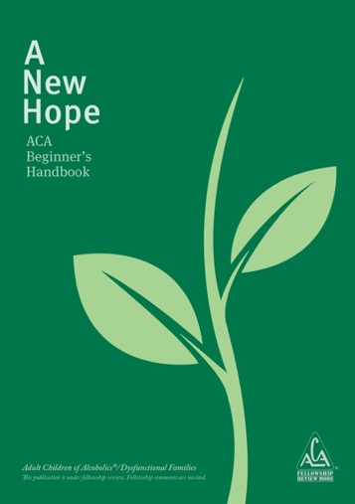 | A New Hope. ACA Beginner's Handbook. An image of a stylized sprout in light green on dark green background. This represents something new that is growing. A logo of Adult Children of Alcoholics is comprised of the acronym, A C A written inside a triangle. The registered trademark symbol, R inside the circle, appears to the right of the logo. Below the triangle the words Fellowship Review Mode appear. ©2021 Adult Children of Alcoholics®/Dysfunctional Families World Services Organization, Inc. This publication is under fellowship review. Fellowship comments are invited.symbol, R inside the circle, is shown to the right of the logo.
2 | Introduction page |  | An icon of a green sprout.
3 | Title page | 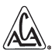 | A logo of Adult Children of Alcoholics is comprised of the acronym, A C A written inside a triangle. The registered trademark symbol, R inside the circle, appears to the right of the logo.
4 | v |  | A blank page with large light grey dots placed in a grid on the page.
5 | 53 |  | A page with a green background color.
6 | BackCover | 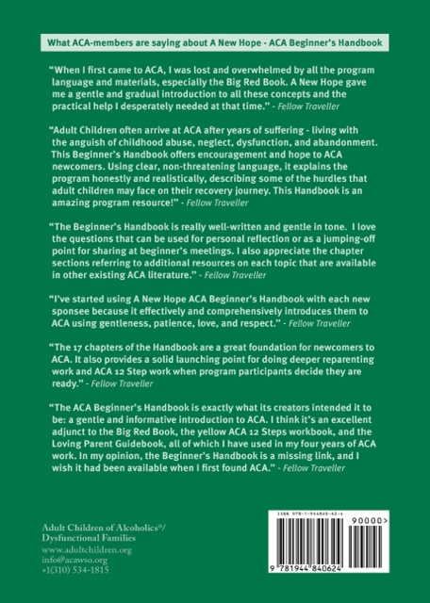 | What ACA-members are saying about A New Hope - ACA Beginner's Handbook.  “When I first came to ACA, I was lost and overwhelmed by all the program language and materials, especially the Big Red Book. A New Hope gave me a gentle and gradual introduction to all these concepts and the practical help I desperately needed at that time.” - Fellow Traveller  “Adult Children often arrive at ACA after years of suffering - living with the anguish of childhood abuse, neglect, dysfunction, and abandonment. This Beginner’s Handbook offers encouragement and hope to ACA newcomers. Using clear, non-threatening language, it explains the program honestly and realistically, describing some of the hurdles that adult children may face on their recovery journey. This Handbook is an amazing program resource!” - Fellow Traveller  “The Beginner’s Handbook is really well-written and gentle in tone. I love the questions that can be used for personal reflection or as a jumping-off point for sharing at beginner’s meetings. I also appreciate the chapter sections referring to additional resources on each topic that are available in other existing ACA literature.” - Fellow Traveller  “I’ve started using A New Hope ACA Beginner’s Handbook with each new sponsee because it effectively and comprehensively introduces them to ACA using gentleness, patience, love, and respect.” - Fellow Traveller  “The 17 chapters of the Handbook are a great foundation for newcomers to ACA. It also provides a solid launching point for doing deeper reparenting work and ACA 12 Step work when program participants decide they are ready.” - Fellow Traveller  “The ACA Beginner’s Handbook is exactly what its creators intended it to be: a gentle and informative introduction to ACA. I think it’s an excellent adjunct to the Big Red Book, the yellow ACA 12 Steps workbook, and the Loving Parent Guidebook, all of which I have used in my four years of ACA work. In my opinion, the Beginner’s Handbook is a missing link, and I wish it had been available when I first found ACA.” - Fellow Traveller  Adult Children of Alcoholics®/Dysfunctional Families  www.adultchildren.org  info@acawso.org  +1(310) 534-1815

