English | Translation
Fellowship Text page 126
Family History Diagram
Great Grandparents
Grandparents
Parents
(Step Parent)
Older
Siblings
Younger
YOU
Spouse / Partner
Your Children

Fellowship Text, page 211
The Fruit
Defects of Character
Feeling Superior
Pettiness
Envy
Perfectionism
Dishonesty
Judge ourselves harshly
Stuff our feelings
Addictive lives
Afraid of people and authority
Self Centeredness
Mistrust
Para alcoholics (codependency)
Reactors rather than actors
Confuse love and pity
Procrastination
Greed
Lust
Isolation
Addicted to excitement
Approval seekers
Self-sacrificial
Judgmental
Terrified of abandonment
The Branches
Laundry List 14 Traits

Fellowship Text page 58
Family Types (Shame circle)
Alcoholic
Addicted
Militaristic
Emotionally Ill Parent
Sexual Abuse
Incest
Hypochondriac Parent
Perfectionistic
Shame
Abondonment

Fellowship Text page xxvi
ACA Disease Model
BODY
PTSD
Stored Trauma
Neglect
MIND
14 Traits
Laundry List
SPIRIT
Hidden Inner Child

Front cover
Adult Children of Alcoholics / Dysfunctional Families
ACA Fellowship Text
The Big Red Book

Meta data
Adult Children of Alcoholics / Dysfunctional Families

Healing our harmful personality traits developed from childhood trauma received by growing up in dysfunctional and abusive families

Author: ACA WSO INC.
This is official Adult Children of Alcoholics World Service Organization (ACA WSO) Conference Approved Literature.

The ACA Fellowship Text (commonly referred to as the Big Red Book or BRB) is a meeting book, Steps book, Traditions book, workbook, and group guide. The ACA Fellowship Text was anonymously written by ACA members and provides guidance on working the 12 Step ACA program leading to recovery from the effects of growing up in an alcoholic or otherwise dysfunctional family. ACA WSO has adapted AA's Steps (with permission from AA) to address the effects of childhood trauma and neglect, and offer hope to ACAs worldwide.”

Never before in the history of Twelve Step programs has a fellowship brought together such a diverse group of recovering people that includes adult children of alcoholics, codependents,
and addicts of various sorts. The program is Adult Children of Alcoholics. The term “adult child” is used to describe adults who grew up in alcoholic or dysfunctional homes and who exhibit
identifiable traits that reveal past abuse or neglect. The group includes adults raised in homes without the presence of alcohol or drugs. These ACA members have the trademark presence of
abuse, shame, and abandonment found in alcoholic homes.

ACA experience shows that survival traits developed by an abused or neglected child continue to affect the adult in problematic ways that our fellowship understands and addresses.
We offer hope and a sense of home for many adult children who live each day in quiet desperation without words to describe such despair.

Clinical and medical researchers have measured the causes and effects of growing up in a dysfunctional home and how such trauma continues to affect the affected adults throughout their lives. Our book also offers a medical opinion on this fact in its introductory pages.

No matter whether there was alcohol, drugs, gambling, sex abuse, physical abuse, neglect, or actions by immature parents, we develop similar traits or characteristics that interfere with our ability to form happy and healthy relationships with partners, at work, and anywhere else that fear and self-doubt can enter into our lives.
By finding a twelve steps meeting of adult children of alcoholics and working through this book and reparenting yourself, you will come to know a new way to live that will relieve the pain, shame, and years of stored anger you have endured since childhood.

Our fellowship includes members who have been diagnosed with addictions, depression, panic disorders, post-traumatic stress disorder, and various dissociative states. Adult children
understand dissociation, codependence, obsession, and compulsion like few others.
Twelve steps 12 steps laundry list ACA WSO complex PTSD mental health self-help love reparenting how to heal your inner adult child children of alcoholics healing developmental trauma recovery inner child workbook book for women codependence journal yourself.

Alcoholism
12 Steps
Adult Children Workbook
Dysfunctional
Post Traumatic Stress Disorder
Alcoholics Immature parents
Cycle of violence dissociation problem serenity
Addiction recovery emotionally unavailable
- Nonfiction > Family & Relationships > Dysfunctional Families
- Nonfiction > Self-Help > Abuse

Alt-text
Sr. no. | Print page no. | PDF Screenshot | English: Alt-text description | Translation:
1 | Cover | 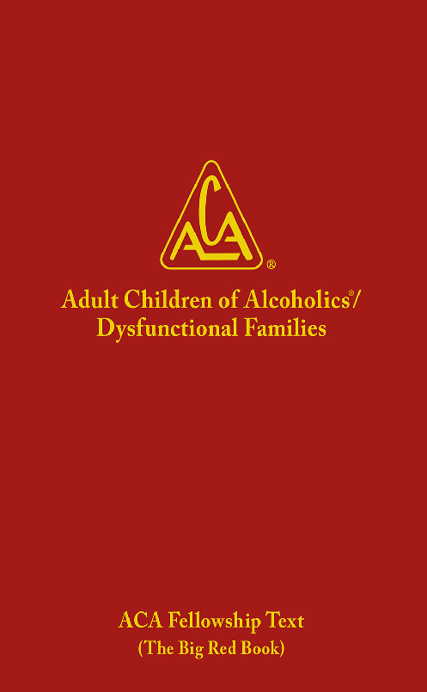 | An image shows the cover page of The Big Red Book. The center of the book has the logo of Adult Children of Alcoholics or Dysfunctional Families. The logo is comprised of the acronym, A C A written inside a triangle. The registered trademark symbol, R inside the circle, appears to the right of the logo. Text at the bottom of the cover page reads, A C A Fellowship Text, The Big Red Book.
2 | iii | 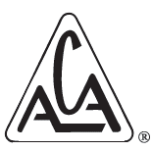 | A logo of Adult Children of Alcoholics is comprised of the acronym, A C A written inside a triangle. The registered trademark symbol, R inside the circle, appears to the right of the logo.
3 | xxvi | 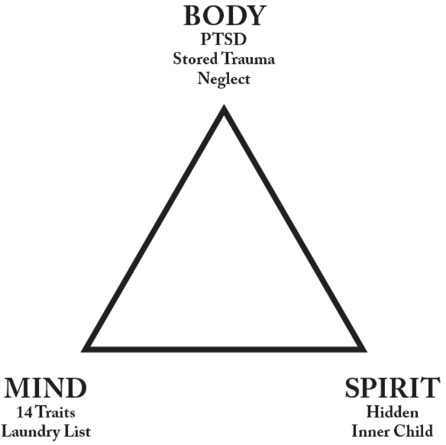 | A triangle is used to represent the disease of family dysfunction. The top vertex of the triangle is the Body which stores the trauma and neglect in the form of P T S D. The bottom left vertex of the triangle is the Mind which develops the 14 traits of the Laundry list. The bottom right vertex of the triangle is the Spirit which includes the hidden inner child.
4 | 58 | 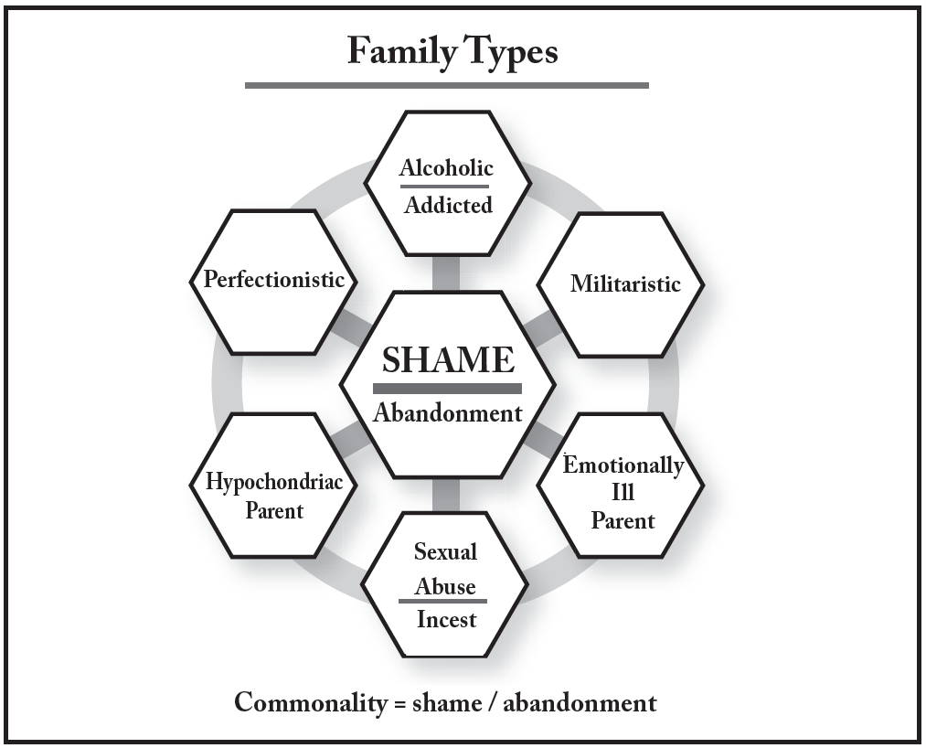 | A graphic presents the different types of family. The commonality, at the center of the graphic and connected to each family type, is shame and abandonment. The six different types of family are: Alcoholic addicted, Militaristic, Emotionally ill parent, Sexual abuse including incest, Hypochondriac parent, and Perfectionist.
5 | 125 | 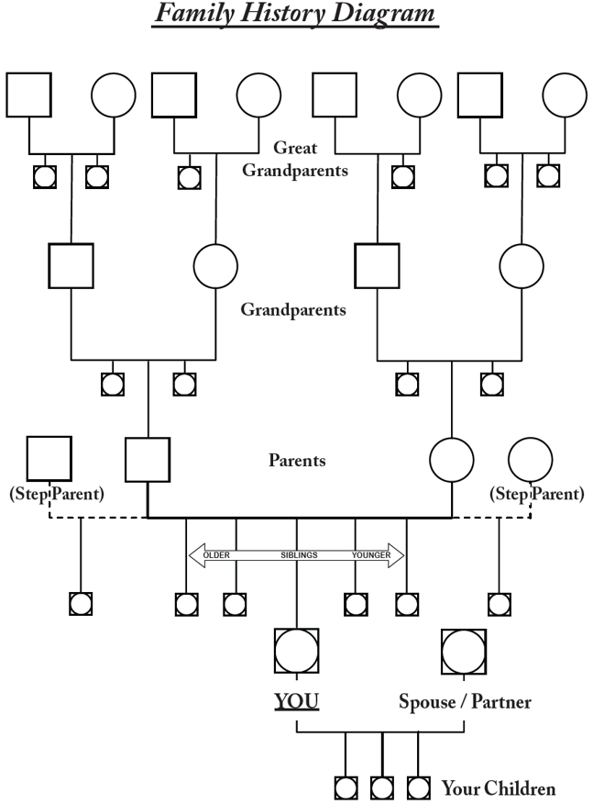 | A family history diagram has four stages, with the top stage or row for your maternal and paternal Great Grandparents. The next row underneath them are your maternal and paternal Grandparents and their siblings. The third row is for your Parents and/or Step Parents, and their siblings. The fourth row is for You, your spouse and your siblings. Underneath your row are you children. The symbols used in the diagram are a square representing one great grandparent, grandparent or parent and a circle representing their significant other. A circle inscribed in a square represents siblings of the persons named in the circles and squares on the row. For example if the parents and/or step parents row has squares with circles inside them dropping down from your row they would be your siblings. If your grandparents have squares with circles in them dropping down on the same level as your parents they would be your aunts and uncles. The objective of this exercise is to use this diagram's structure to fill in as many names as you can where they belong and to reflect on each of them and jot down whatever dysfunction they brought to the family. For example a great grandparent might have been an alcoholic. A grandparent might have been a sex abuse victim. One parent might have been a workaholic and the other a drug addict. An aunt may have been obese and a food addict. An uncle might have been depressed and committed suicide. The goal is to see how generational dysfunction is passed down from generation to generation.
6 | 206 | 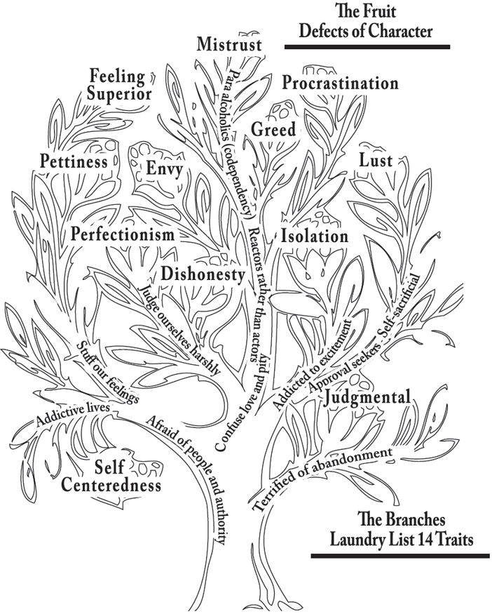 | A graphic uses a tree to represent the fourteen traits of the Laundry list and the defects of the character. The branches of the tree represent the fourteen traits of the Laundry list, from the bottom to the top of the tree, as follows: Afraid of people and authority, Terrified of abandonment, Addictive lives, Stuff our feelings, Judge ourselves harshly, Confuse love and pity, Addicted to the excitement, Approval seekers, Self sacrificial, Reactors rather than actors, Isolation, Para alcoholics or co-dependency, Mistrust, and feeling superior. The fruits depict the possible defects of character, from bottom to top of the tree, as follows: Self-centeredness, Judgmental, Perfectionism, Dishonesty, Pettiness, Envy, Greed, Lust, Feeling superior, and Procrastination.

