English | Translation  N.B. Submit case sensitive

Front cover
THE LAUNDRY LISTS WORKBOOK
Integrating Our Laundry Lists Traits
Back cover
WHOLE
HEALTHY
SANE
AND SAFE

The Complete Picture pages x–xi / pages 152–153
THE COMPLETE PICTURE
Characteristics of an Adult Child
A reaction Formation List; “It Will Never Happen To Me
Victim / Rescuer I
Unintegrated and emotionally intoxicated
Rescuer II / Persecutor
In the “Game” of Dissociation these positions are receivers of insult & injury delivered by dissociative dosing transactions.
In the “Game” of Dissociation these positions are givers of insult & injury* delivered by dissociative dosing transactions.
Completing the Cycle of Violence
Closing the Circle
Positions in The Game of Dissociation
Male Victim
Overt Victim
Covert Victimizer
Male Victimizer
Overt Victimizer
Covert Victim
Female Victim
Overt Victim
Covert Victimizer
Female Victimizer
Overt Victimizer
Covert Victim
The Apprentice / The Child
Bringing the Family Drama to a Close
Withdrawing from The Game of Dissociation
Persecutor
Rescuer
Type I & II
Victim
The Drama Triangle
Sober Side of the Self
A Fourth Possibility
Completing the Recovery Process
Whole, healthy, sane & safe
The Sober Self
Characteristics of an Integrated Person
Note: Insult and Injury = Punishment, abandonment, conditional acceptance, conditional care
Oh, No! These are my choices?
Following Karpman 1967, 2007
For an explanation of the roles and transactions in the “Game” of Dissociation, see p. 155.

G.O.D page 175
AWARENESS
ungrounded
Semi-awareness
Semi-consciousness
CONSCIOUSNESS
grounded
STRESS
TRAUMA

Meta data
The Laundry Lists Workbook
Integrating Our Laundry List Traits
This is official Adult Children of Alcoholics World Service Organization (ACA WSO) Conference Approved Literature.

The Laundry Lists Workbook is a workbook that was anonymously written by and for the Adult Children of Alcoholics (ACA/ACoA) Fellowship. The seeds of this book were planted during the final development of the Fellowship Text, also known as the Big Red Book (BRB). When the ACA Fellowship Text was being reviewed, a copy was sent to a member who thought the book was great, except that it did not mention how we “act out” The Laundry List effects.

While the original Laundry List describes how we were affected by alcoholism and family dysfunction, the member pointed out that as adults, we might, in turn, “act out” those traits by becoming victimizers. In other words, adult children, by adopting their parents’ behaviors, “become” their parents. That simple observation planted the seed for the development of The Other Laundry List and provides a fuller picture of how we are affected by the effects of alcoholism and family dysfunction.

Please note that this workbook is for ACAs who are ready to embark on advanced work on
their survival traits. It is designed for ACAs who have already gone through all the Steps in
the ACA Twelve Steps Workbook. Since the nature of integrating our laundry lists traits can
be quite involved, we suggest the use of a separate notebook for recording in-depth reflections,
journaling, and for exploring non-dominant handwriting.

Some adult children also may meet informally to work through The Laundry Lists Workbook.
These groups should adhere to the principles and traditions of ACA groups. Each participant
should agree to practice honesty and courtesy, in addition to helping keep the group safe. The
principle of anonymity should be honored as well.

”The Workbook expands the brief description of the "Other" or Opposite Laundry List (BRB, p. 8). It contains concise questions to guide the recovering adult child in reliving actual episodes that produced feelings of inferiority, shame, guilt, and anger (emotional intoxication). This workbook outlines a recovery process for healing the injury and conflict caused by childhood trauma and its continued reenactment, and for withdrawing from emotional intoxication.”

What is an Adult Child?
The concept of Adult Child is someone whose actions and decisions as an adult are guided by childhood experiences grounded in self-doubt or fear. As children, most of us quickly figured out what we needed to think, say, and do to avoid the most pain. We survived the best way we could, relying on only ourselves to get by. Often, we stay in abusive relationships because they resemble how we were raised.

No matter whether there was alcohol, drugs, gambling, sex abuse, overeating, codependent behavior, physical abuse, neglect, abandonment or actions by immature parents, we develop similar traits or characteristics that interfere with our ability to form happy and healthy relationships with partners, at work, and anywhere else that fear and self-doubt can enter into our lives.
By finding a twelve steps meeting of adult children of alcoholics and learning to reparent yourself, you will come to know a new way to live that will relieve the pain, shame, and years of stored anger you have endured since childhood.
We learn to heal our harmful personality Laundry List Traits developed from childhood trauma we received by growing up in dysfunctional and abusive families.
Twelve steps 12 steps laundry list ACA WSO complex emotional sobriety PTSD triggers authority figures mental health self-help love reparenting how to heal your inner adult child children of alcoholics healing developmental trauma recovery inner child workbook book for women codependence journal yourself.

Twelve Steps
Adult Children Affirmations
Dysfunctional trauma
Alcoholics Immature parents
ACA Schematic dissociation serenity
Addiction recovery emotionally unavailable

Alt-text
Sr. no. | Print page no. | PDF Screenshot | English: Alt-text description | Translation:
1 | Front cover | 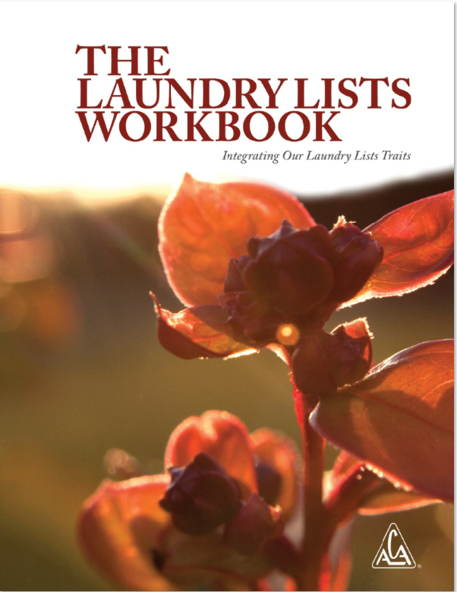 | An image shows the cover page of a book. The title reads, The Laundry Lists Workbook. The text below the title reads, Integrating our laundry lists traits. There is a picture of a plant with flowers, buds, and leaves. A logo of the acronym, A C A inside a triangle is at the bottom right. The registered trademark symbol, R inside the circle, is shown to the right of the logo.
2 | Flower image | 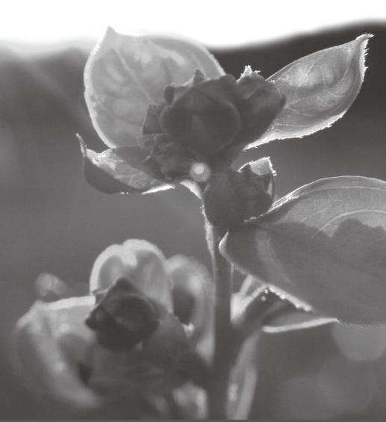 | A plant with flowers, buds and leaves.
3, 4 | x-xi,  152-153 | 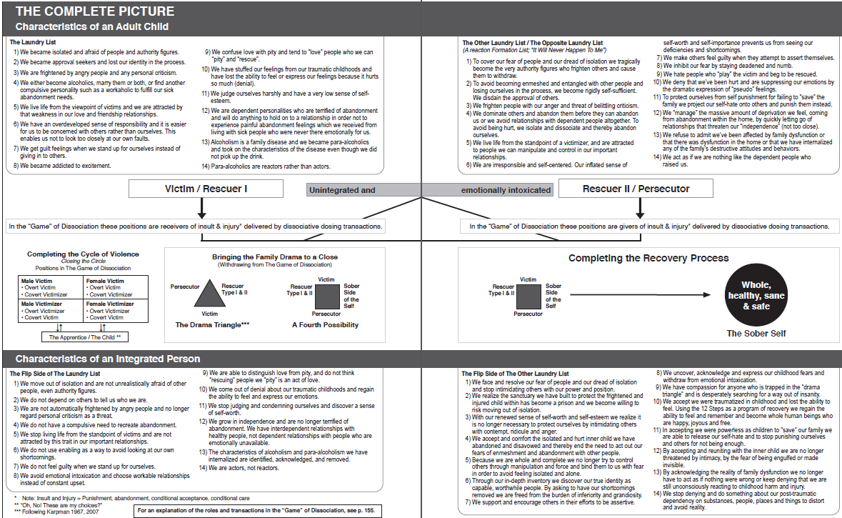 | A chart titled, the complete picture, presents the characteristics of an adult child in a dysfunctional family, the recovery process to become a sober self, and the characteristics of an integrated person.  The characteristics of an adult child are as follows. The laundry list reads as follows.1, We became isolated and afraid of people and authority figures. 2, We became approval seekers and lost our identity in the process. 3, We are frightened by angry people and any personal criticism. 4, We become alcoholics, marry them or both, or find another compulsive personality such as a workaholic to fulfill our sick abandonment needs. 5, We live life from the viewpoint of victims and we are attracted by that weakness in our love and friendship relationships. 6, We have an overdeveloped sense of responsibility and it is easier for us to be concerned with others rather than ourselves. This enables us not to look too closely at our own faults. 7, We get guilt feelings when we stand up for ourselves instead of giving in to others. 8, We became addicted to excitement. 9, We confuse love with pity and tend to love people who we can pity and rescue. 10, We have stuffed our feelings from our traumatic childhoods and have lost the ability to feel or express our feelings because it hurts so much, denial. 11, We judge ourselves harshly and have a very low sense of self-esteem. 12, We are dependent personalities who are terrified of abandonment and will do anything to hold on to a relationship in order not to experience painful abandonment feelings which we received from living with sick people who were never there emotionally for us. 13, Alcoholism is a family disease and we became para-alcoholics and took on the characteristics of the disease even though we did not pick up the drink. 14, Para-alcoholics are reactors rather than actors. The other laundry list or the opposite laundry list which is a reaction formation list, that is, it will never happen to me, reads as follows. 1,To cover our fear of people and our dread of isolation we tragically become the very authority figures who frighten others and cause them to withdraw. 2, To avoid becoming enmeshed and entangled with other people and losing ourselves in the process, we become rigidly self-sufficient. We disdain the approval of others. 3, We frighten people with our anger and threat of belittling criticism. 4, We dominate others and abandon them before they can abandon us or we avoid relationships with dependent people altogether. To avoid being hurt, we isolate and dissociate and thereby abandon ourselves. 5, We live life from the standpoint of a victimizer, and are attracted to people we can manipulate and control in our important relationships. 6, We are irresponsible and self-centered. Our inflated sense of self-worth and self-importance prevents us from seeing our deficiencies and shortcomings. 7, We make others feel guilty when they attempt to assert themselves. 8, We inhibit our fear by staying deadened and numb. 9, We hate people who play the victim and beg to be rescued.10, We deny that we have been hurt and are suppressing our emotions by the dramatic expression of pseudo feelings. 11, To protect ourselves from self punishment for failing to save the family we project our self-hate onto others and punish them instead. 12, We manage the massive amount of deprivation we feel, coming from abandonment within the home, by quickly letting go of relationships that threaten our independence, not too close. 13, We refuse to admit we have been affected by family dysfunction or that there was dysfunction in the home or that we have internalized any of the family’s destructive attitudes and behaviors. 14, We act as if we are nothing like the dependent people who raised us.  The two types of positions in the dissociation are as follows. The victim or rescuer 1: In the game of dissociation these positions are receivers of insult and injury delivered by dissociative dosing transactions. Rescuer 2 or persecutor: In the game of dissociation these positions are givers of insult and injury delivered by dissociative dosing transactions. Both the positions are unintegrated and emotionally intoxicated. A section reads completing the cycle of violence; closing the circle, depicts the four positions in the game of dissociation. The four positions are: male victim: overt victim, covert victimizer; female victim: overt victim, covert victimizer; male victimizer: overt victimizer, covert victim; female victimizer: covert victimizer, covert victim. The apprentice or the child is associated with the four positions and vice verse. The segment, bringing the family drama to a close, withdrawing from the game of dissociation is depicted as follows. The dram triangle comprises of persecutor, rescuer type 1 and 2 and the victim along the three sides of a triangle. A fourth possibility is depicted as victim, rescuer type 1 and 2, persecutor and sober side of the self on the four sides of a square. The segment, completing the recovery process is depicted as follows. The square depicting the fourth possibility leads to the sober self who is whole, healthy, sane and safe.  The characteristics of an integrated person are as follows. The Flip Side of The Laundry List. 1, We move out of isolation and are not unrealistically afraid of other people, even authority figures. 2, We do not depend on others to tell us who we are. 3, We are not automatically frightened by angry people and no longer regard personal criticism as a threat. 4, We do not have a compulsive need to recreate abandonment. 5, We stop living life from the standpoint of victims and are not attracted by this trait in our important relationships. 6, We do not use enabling as a way to avoid looking at our own shortcomings. 7, We do not feel guilty when we stand up for ourselves. 8, We avoid emotional intoxication and choose workable relationships instead of constant upset. 9, We are able to distinguish love from pity, and do not think rescuing people we pity is an act of love. 10, We come out of denial about our traumatic childhoods and regain the ability to feel and express our emotions.11, We stop judging and condemning ourselves and discover a sense of self-worth. 12, We grow in independence and are no longer terrified of abandonment. We have interdependent relationships with healthy people, not dependent relationships with people who are emotionally unavailable. 13, The characteristics of alcoholism and para alcoholism we have internalized are identified, acknowledged, and removed. 14, We are actors, not reactors. A note with an asterisk symbol reads: Insult and injury equals punishment, abandonment, conditional acceptance and conditional care. The text below with two asterisk symbol reads, Oh no! These are my choices? The text below with three asterisk symbols read, following Karpman 1967, 2007. For an explanation of the roles and transactions in the game of dissociation, see page 155. The flip side of the other laundry list is as follows. 1, We face and resolve our fear of people and our dread of isolation and stop intimidating others with our power and position. 2, We realize the sanctuary we have built to protect the frightened and injured child within has become a prison and we become willing to risk moving out of isolation. 3, With our renewed sense of self-worth and self-esteem we realize it is no longer necessary to protect ourselves by intimidating others with contempt, ridicule and anger.4, We accept and comfort the isolated and hurt inner child we have abandoned and disavowed and thereby end the need to act out our fears of enmeshment and abandonment with other people. 5, Because we are whole and complete, we no longer try to control others through manipulation and force and bind them to us with fear in order to avoid feeling isolated and alone. 6, Through our in-depth inventory we discover our true identity as capable, worthwhile people. By asking to have our shortcomings removed we are freed from the burden of inferiority and grandiosity. 7, We support and encourage others in their efforts to be assertive. 8, We uncover, acknowledge and express our childhood fears and withdraw from emotional intoxication. 9, We have compassion for anyone who is trapped in the drama triangle and is desperately searching for a way out of insanity. 10, We accept we were traumatized in childhood and lost the ability to feel. Using the 12 Steps as a program of recovery we regain the ability to feel and remember and become whole human beings who are happy, joyous and free. 11, In accepting we were powerless as children to save our family we are able to release our self-hate and to stop punishing ourselves and others for not being enough. 12, By accepting and reuniting with the inner child we are no longer threatened by intimacy, by the fear of being engulfed or made invisible. 13, By acknowledging the reality of family dysfunction we no longer have to act as if nothing were wrong or keep denying that we are still unconsciously reacting to childhood harm and injury. 14, We stop denying and do something about our post-traumatic dependency on substances, people, places and things to distort and avoid reality.
5 | 156 |  | A logo of Adult Children of Alcoholics is comprised of the acronym, A C A written inside a triangle. The registered trademark symbol, R inside the circle, appears to the right of the logo.
6 | 175 | 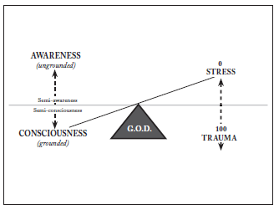 | A model depicts the relationship between awareness, consciousness, stress, trauma and G O D. A balance scale represents G O D. The arms of the scale are low on the left, and high on the right. On the left, the terms awareness and consciousness are placed above and below the arm of the scale, respectively. On the right, the terms stress and trauma are placed above and below the arm of the scale, respectively. A dotted, vertical line from stress and trauma reads 0 on the top and 100 on the bottom. On the left, a dotted, vertical line from awareness and consciousness reads ungrounded on the top and grounded on the bottom. The terms semi-awareness and semi-consciousness are given along the dotted vertical line, above and below the horizontal line passing through the apex of the triangle. A diagonal line from stress to consciousness passes through the apex of the triangle.

