English | Translation

Cover
Daily Affirmations
Strengthening My Recovery

Meditations for Adult Children for Alcoholics/Dysfunctional Families
First Edition

Meta data
Strengthening My Recovery

Daily Affirmations and Meditations for Adult Children of Alcoholic and Dysfunctional Families

Description
This is official Adult Children of Alcoholics World Service Organization (ACA WSO) Conference Approved Literature. This eBook version has been upgraded to the epub 3.0 format which includes improved accessibility features.

Strengthening My Recovery was anonymously written by ACA members and is a Daily Meditation Book written by and for the Adult Children of Alcoholics (ACA/ACoA)
Fellowship. The seeds of this book were planted during the final development of the Fellowship Text, also known as the Big Red Book (BRB).

Each meditation starts with a quote from the BRB. The writer’s recovery experience is then shared. The affirmation at the end is intended as a message of hope to carry us through our day. The volunteers were asked to write in the nominative, plural case (the “we” format). Although their observations may be personal in nature, they are also thought to be universal to most of us. Using the nominative case makes them our stories, reminding us that we are a recovery family.

It should be noted that “Strengthening Our Recovery” is not meant to facilitate study of the BRB. It is meant as a companion to the BRB and our Twelve Steps of Adult
Children Workbook. Taken together, they are powerful tools for recovery that complement each other. In addition to making this book a part of your personal daily recovery reading, we hope that each group will read the meditation of the day as part of their meeting format.

What is an Adult Child?
The concept of Adult Child is someone whose actions and decisions as an adult are guided by childhood experiences grounded in self-doubt or fear. As children, most of us quickly figured out what we needed to think, say, and do to avoid the most pain. We survived the best way we could, relying on only ourselves to get by. Often, we stay in abusive relationships because they resemble how we were raised.

No matter whether there was alcohol, drugs, gambling, sex abuse, overeating, codependent behavior, physical abuse, neglect, abandonment or actions by immature parents, we develop similar traits or characteristics that interfere with our ability to form happy and healthy relationships with partners, at work, and anywhere else that fear and self-doubt can enter into our lives.
By finding a twelve steps meeting of adult children of alcoholics and learning to reparent yourself, you will come to know a new way to live that will relieve the pain, shame, and years of stored anger you have endured since childhood.
Healing our harmful personality laundry list traits developed from childhood trauma received by growing up in dysfunctional and abusive families
Twelve steps 12 steps laundry list ACA WSO complex emotional sobriety PTSD triggers authority figures mental health self-help love reparenting how to heal your inner adult child children of alcoholics healing developmental trauma recovery inner child workbook book for women codependence journal yourself.

Keywords

Twelve Steps
Adult Children Affirmations
Dysfunctional
Alcoholics Immature parents
Cycle of violence dissociation problem serenity
Addiction recovery emotionally unavailable
- Nonfiction > Family & Relationships > Dysfunctional Families
- Nonfiction > Self-Help > Affirmations

Alt-text
Sr. no. | Print page no. | PDF Screenshot | English: Alt-text description | Translation:
1 | Cover | 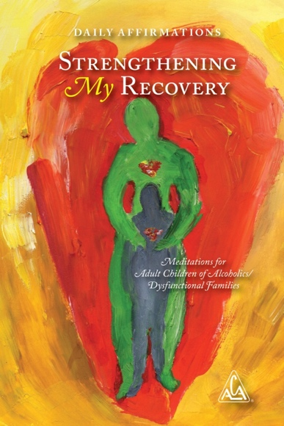 | An image shows the cover page of a book. The title reads, Strengthening My Recovery. The text above the title reads, Daily Affirmations. The text near the bottom of the page reads, Meditations for Adult Children of Alcoholics or Dysfunctional families. The cover page is a painting of a person embracing an adult child from the back. A logo of the acronym, A C A inside a triangle is at the bottom right. The registered trademark symbol, R inside the circle, is shown to the right of the logo.
2 | i | 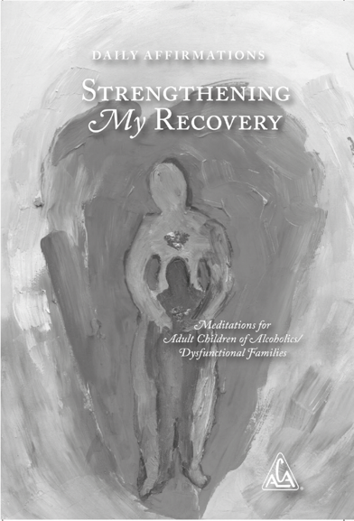 | An image shows the black and white image of the cover page of a book. The title reads, Strengthening My Recovery. The text above the title reads, Daily Affirmations. The text near the bottom of the page reads, Meditations for Adult Children of Alcoholics or Dysfunctional families. The cover page is a painting of a person embracing an adult child from the back. A logo of the acronym, A C A inside a triangle is at the bottom right. The registered trademark symbol, R inside the circle, is shown to the right of the logo.
3 | iii | 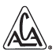 | A logo of Adult Children of Alcoholics is comprised of the acronym, A C A written inside a triangle. The registered trademark symbol, R inside the circle, appears to the right of the logo.
4 | v | 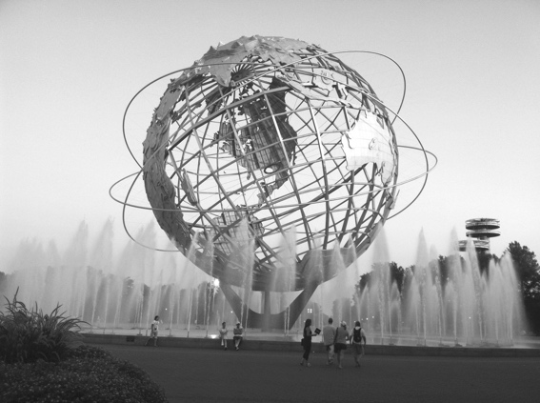 | A picture of the Unisphere globe designed for the 1964 New York World’s Fair. It was chosen to represent the vast possibilities of our Global fellowship.
5 | 1 | 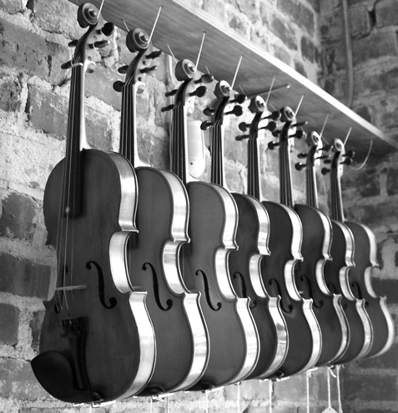 | A photo of identical violins hanging in a row. This is symbolic of how we are equals in the rooms of ACA, no matter what our specific circumstances, no matter which tune we play in the outside world.
6 | 33 | 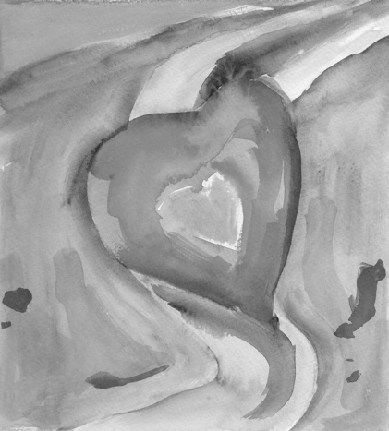 | An image of a heart within a heart that seems to be floating in the breeze, similar to a kite. This symbolizes how we move together through the winds of recovery.
7 | 63 | 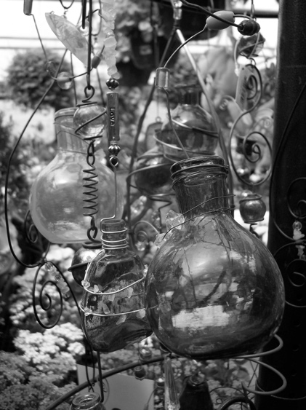 | A photo of many different shapes and sizes of glass containers to symbolize how we are each different and intricate. But we have the patience and love to support each other through our recovery – a process that is not easy.
8 | 103 | 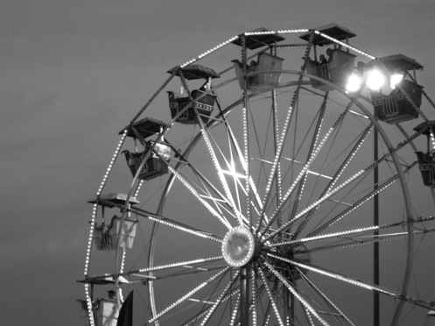 | A photo of the upper portion of a carnival Ferris Wheel. Up there it can feel shaky and we may even feel a loss of control. But recovery helps us surrender and appreciate the journey.
9 | 126 | 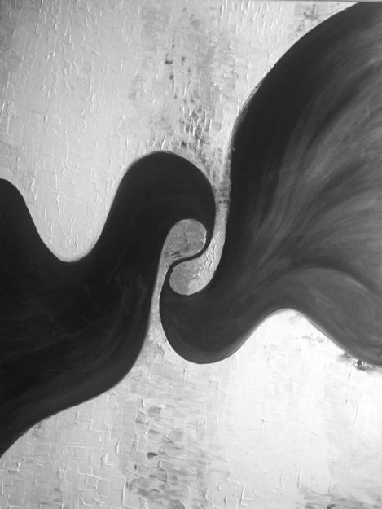 | A watercolor of two swirling shapes that are actually connected, much as we can find connection with each other through the ACA Program.
10 | 158 | 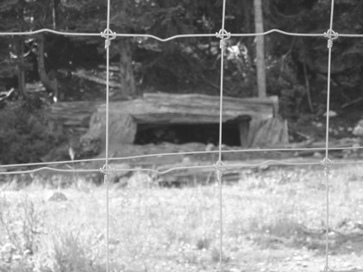 | A photo of an enclosure with a den for wild animals taken at Grouse Mountain in Vancouver, BC, Canada. Because we are outside of the enclosure, it symbolizes the freedom we feel when we can separate ourselves from the dysfunction of our families.
11 | 189 | 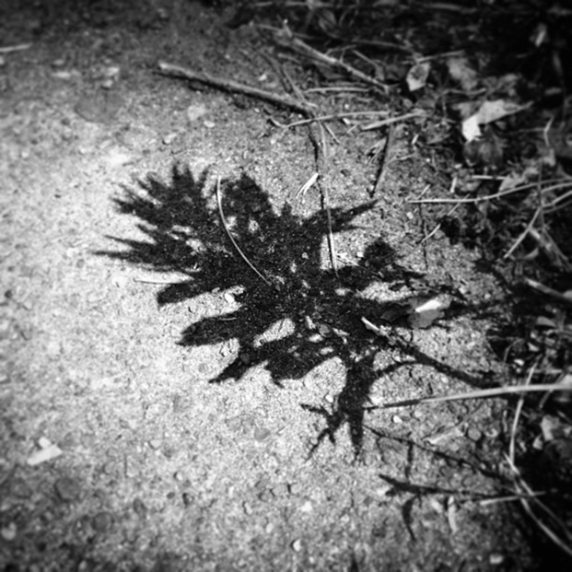 | A photo of a single leaf that seems to have withered  when it is alone with no connection to other, healthier  vegetation.
12 | 221 | 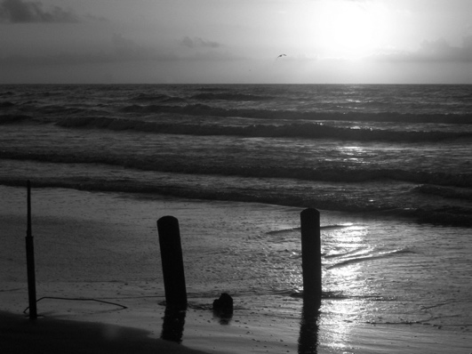 | A photo of calm waters as viewed from a pier, meant to symbolize the safety of being on the recovery journey with other ACAs.
13 | 253 | 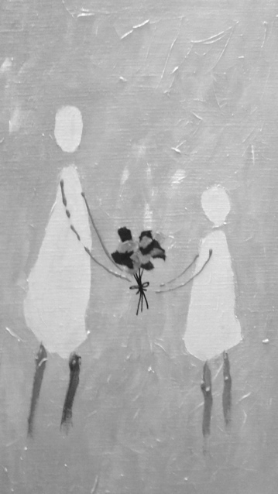 | An image of one person giving a bouquet of flowers to the other. This symbolizes the gift of support we give each other in ACA.
14 | 284 | 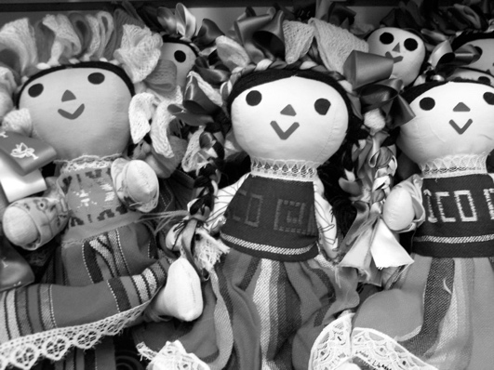 | A photo of many smiling handmade dolls. This symbolizes both the comforting nature of a doll for our Inner Child as well as a reminder to play and have fun as our recovering adult selves.
15 | 316 |  | A drawing of an adult holding a child while reaching for a large heart floating in the air. This symbolizes how we grow in ACA as we see the possibilities and open our hearts to experience the person we are meant to be.
16 | 347 | 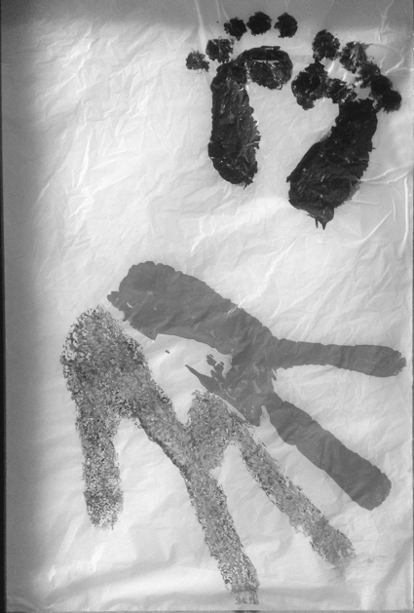 | A large piece of crinkled paper with a child’s footprints and a parent’s handprint. Because they are facing in opposite directions, it symbolizes a lack of connection – an abandonment.

