English | Translation

Steps Workbook
ACA Steps Workbook (headline on each page)
Twelve Steps of Adult Children (headline on each page)

Workbook page 36 / Fellowship Text page 126
Family History Diagram
Great Grandparents
Grandparents
Parents
(Step Parent)
Older
Siblings
Younger
YOU
Spouse / Partner
Your Children

Workbook page 120, Fellowship Text, page 211
The Fruit
Defects of Character
Feeling Superior
Pettiness
Envy
Perfectionism
Dishonesty
Judge ourselves harshly
Stuff our feelings
Addictive lives

Afraid of people and authority
Self Centeredness
Mistrust
Para alcoholics (codependency)
Reactors rather than actors
Confuse love and pity
Procrastination
Greed
Lust
Isolation
Addicted to excitement
Approval seekers
Self-sacrificial
Judgmental
Terrified of abandonment
The Branches Laundry List 14 Traits
Workbook front cover
Twelve Steps of Adult Children
Mistrust
Perfectionism
Judge ourselves harshly
Stuff our feelings
Addictive lives
Afraid of people and authority
Self Centeredness
Para alcoholics (codependency)
Reactors rather than actors
Confuse love and pity
Procrastination
Isolation

Addicted to excitement
Approval seekers
Self-sacrificial
Terrified of abandonment
Workbook back cover
Feeling
Maturity
Joy
Accepting Mistakes
Honesty
Accepting Help
Reparent
Emotional Sobriety
Trust
Action
Service
Self Love
Friendship
Spirituality
Integrated
Meta data
Twelve Steps of Adult Children - Steps Workbook

Twelve Steps of Adult Children

Steps Workbook
Healing our harmful personality traits developed from childhood trauma received by growing up in dysfunctional and abusive families
ACA WSO INC.
This is official Adult Children of Alcoholics World Service Organization (ACA WSO) Conference Approved Literature.

The ACA Twelve Steps of Adult Children (commonly referred to as the Yellow Workbook or YWB) is a Steps workbook. The ACA Yellow Workbook was anonymously written by ACA members and provides guidance on working the 12 Step ACA program leading to recovery from the effects of growing up in an alcoholic or otherwise dysfunctional family. ACA WSO has adapted AA's Steps (with permission from AA) to address the effects of childhood trauma and neglect and offer hope to Adult Children worldwide.

The Twelve Steps of Adult Children Workbook provides members with a detailed series of exercises and questionnaires that can be used by individuals either in a one-on-one Fellow Traveler (Sponsorship) or in group studies. This workbook describes the 12 steps of ACA used to achieve recovery from the dysfunctional traits of codependence that children develop and carry into adulthood as a result of growing up in dysfunctional families, no matter the cause of the dysfunction.

What is an Adult Child?
“The concept of Adult Child came from the Alateens who began the Hope for Adult Children
of Alcoholics meeting. The original members of our fellowship, who were over eighteen years
old, were adults; but as children they grew up in alcoholic homes. Adult Child also means that
when confronted, we regress to a stage in our childhood.” ACA History—an interview with
Tony A., 1992.

The solution is to become your own loving parent. As ACA becomes a safe place for you,
you will find freedom to express all the hurts and fears that you have kept inside and to free
yourself from the shame and blame that are carry-overs from the past. You will become an
adult who is imprisoned no longer by childhood reactions. You will recover the child within
you, learning to love and accept yourself.

The healing begins when we risk moving out of isolation. Feelings and buried memories
will return. By gradually releasing the burden of unexpressed grief, we slowly move out of the
past. We learn to reparent ourselves with gentleness, humor, love and respect. This process
allows us to see our biological parents as the instruments of our existence. Our actual parent
is a Higher Power whom some of us choose to call God. Although we had alcoholic or dysfunctional parents, our Higher Power gave us the Twelve Steps of Recovery.

This is the action and work that heals us: we use the Steps; we use the meetings; we use the
telephone. We share our experience, strength, and hope with each other. We learn to restructure our sick thinking one day at a time. When we release our parents from responsibility for our actions today, we become free to make healthy decisions as actors, not reactors. We progress from hurting, to healing, to helping. We awaken to a sense of wholeness we never knew was possible.

The ACA Twelve Step workbook was developed during a two-year period, beginning in
2005. As part of the development and input process, ACA groups across the United States read
and used the workbook in small groups and in one-on-one recovery between a sponsor and
sponsee. These working groups submitted input and comments that shaped the tone, focus,
and details of this workbook.

This workbook is a reformatted version of Chapter Seven from the ACA Fellowship Text
(ACA “big book”). Chapter Seven and this workbook are very similar; however, the workbook
has questions at the end of Steps One, Two, and Three and additional writing assignments.

Twelve Steps of Adult Children is designed as a Step-study book and standalone piece of
literature. It can serve as the main piece of literature for Twelve Step discussions at an ACA
meeting. The workbook also is designed to be used by ACA members wanting to work the
ACA Twelve Steps with a sponsor. Along with the writing assignments, there are worksheets
for the Twelve Steps in addition to questions that help unlock clarity about our childhood
experiences and our new path of recovery. For example, Step Four contains 35 pages with
detailed writing and 12 workbook items on shame, abandonment, PTSD, feelings, and sexual
abuse history. The ACA workbook also addresses the topics of grief and integration in addition
to the Twelve Steps.

With some modification the workbook can be used by a group of ACAs wishing to work
the Steps together during a 12-week to 16-week period.

No matter whether there was alcohol, drugs, gambling, sex abuse, physical abuse, neglect, or actions by immature parents, we develop similar traits or characteristics that interfere with our ability to form happy and healthy relationships with partners, at work, and anywhere else that fear and self-doubt can enter into our lives.
By finding a twelve steps meeting of adult children of alcoholics and working through this book and reparenting yourself, you will come to know a new way to live that will relieve the pain, shame, and years of stored anger you have endured since childhood.
Twelve steps 12 steps laundry list ACA WSO complex PTSD mental health self-help love reparenting how to heal your inner adult child children of alcoholics healing developmental trauma recovery inner child workbook book for women codependence journal yourself.

Twelve Steps

Adult Children Workbook

Dysfunctional
Alcoholics Immature parents
Cycle of violence dissociation problem serenity
Addiction recovery emotionally unavailable
- Nonfiction > Family & Relationships > Dysfunctional Families
- Nonfiction > Self-Help > Abuse

Alt-text
Sr. no. | Print page no. | PDF Screenshot | English: Alt-text description | Translation:
1 | Cover | 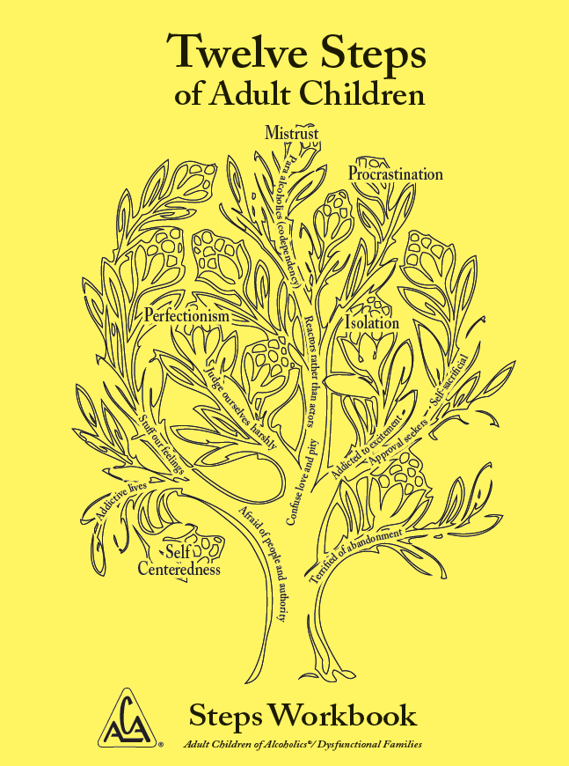 | The front cover of the ACA workbook depicts the Laundry List Tree, which represents the traits of an adult child. The tree also shows the distinction between the traits which are learned in childhood and the defects of character that develop later in life. The Laundry List Traits represent the branches, from the bottom to the top: Afraid of people and authority, Terrified of abandonment, Addictive lives, Stuff our feelings, Judge ourselves harshly, Confuse love and pity, Addicted to the excitement, Approval seekers, Self sacrificial, Reactors rather than actors, and Para alcoholics or codependency. The character defects are the fruit, from the bottom to the top of the tree: Selfcenteredness, Perfectionism, Isolation, Mistrust, and Procrastination.
2 | i | 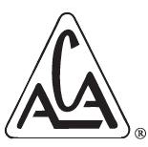 | A logo of Adult Children of Alcoholics is comprised of the acronym, A C A written inside a triangle. The registered trademark symbol, R inside the circle, appears to the right of the logo.
3 | 39 | 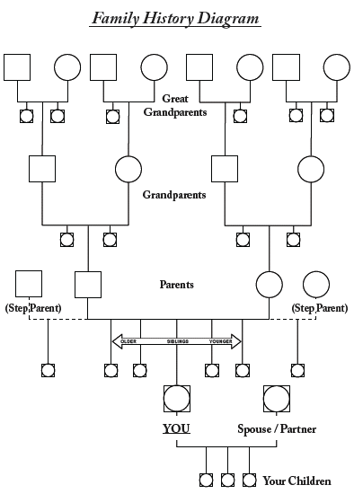 | A family history diagram shows four generations. In the top row there are your maternal and paternal great grandparents. The next row underneath them are your maternal and paternal grandparents and their siblings. The third row is for your parents and/or step parents, and their siblings. The fourth row is for you, your spouse and your siblings. Underneath your row are you children. The symbols used in the diagram are a square representing one great grandparent, grandparent or parent and a circle representing their partner. A circle inscribed in a square represents siblings of the persons named in the circles and squares on the row. For example if the parents and/or step parents row has squares with circles inside them dropping down from your row they would be your siblings. If your grandparents have squares with circles in them dropping down on the same level as your parents they would be your aunts and uncles. The objective of this exercise is to use this diagram's structure to fill in as many names as you can where they belong and to reflect on each of them and jot down whatever dysfunction they brought to the family. For example a great grandparent might have been an alcoholic. A grandparent might have been a sex abuse victim. One parent might have been a workaholic and the other a drug addict. An aunt may have been obese and a food addict. An uncle might have been depressed and committed suicide.  The goal is to see how generational dysfunction is passed down from generation to generation.
4 | 128 | 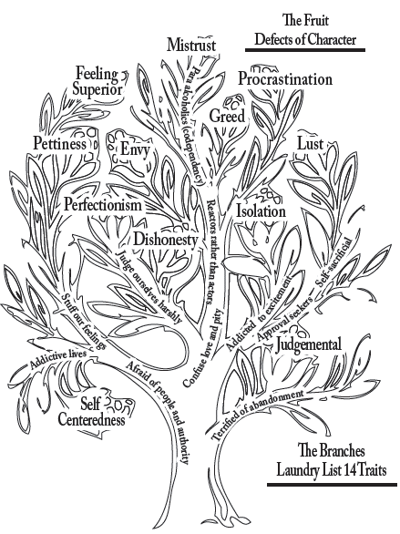 | A graphic uses a tree to represent the fourteen traits of the Laundry list and the defects of the character. The branches of the tree represent the fourteen traits of the Laundry list, from the bottom to the top of the tree, as follows: Afraid of people and authority, Terrified of abandonment, Addictive lives, Stuff our feelings, Judge ourselves harshly, Confuse love and pity, Addicted to the excitement, Approval seekers, Self-sacrificial, Reactors rather than actors and Para alcoholics or co-dependency. The fruits depict the possible defects of character, from bottom to top of the tree, as follows: Self-centeredness, Judgmental, Perfectionism, Dishonesty, Isolation, Pettiness, Envy, Greed, Lust, Feeling superior, Mistrust and Procrastination.
5 | Back cover | 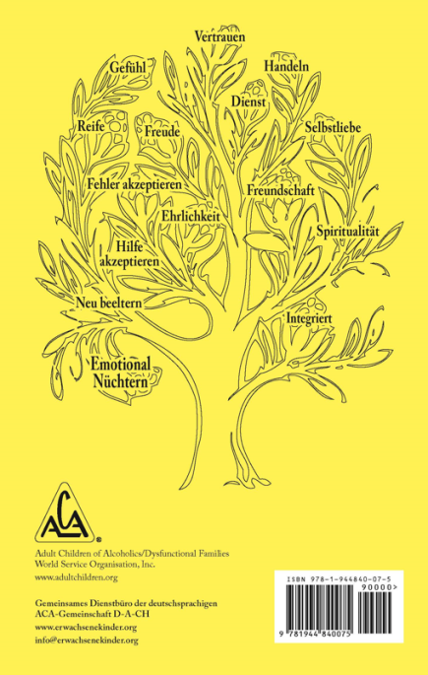 | The back cover depicts the Recovery Tree and the possible results to be realized by working through the ACA Twelve Steps. With recovery, we integrate many of the Laundry List traits, while removing many of the defects of character. The possible results, from the bottom to the top of the tree, are: Emotional sobriety, Integrated,Reparent, Accepting help, Spirituality, Friendship, Honesty, Accepting mistakes, Maturity, Joy, Self Love, Service, Action, and Trust.  A logo consisting of the acronym A C A inside a triangle is at the bottom left. The registered trademark symbol, R inside the circle, is situated to the right of the logo. The text below the logo reads, Adult Children of Alcoholics or Dysfunctional Families, w w w dot adult children dot org, info at a c a w s o dot org, plus 1 310 534 1815. A barcode with the book's I S B N is on the bottom right.

