English | Translation  (Submit translations case sensitive)
Image descriptions
Front cover
The Loving Parent Guidebook
The Solution is to Become Your Own Loving Parent
Adult Children of Alcoholics®/ Dysfunctional Families
This publication is under fellowship review. Fellowship comments are invited.
Back cover
You will recover the child within you,
learning to love and accept yourself.
The Solution really is to become your own loving parent, and this book explains how. Developing your reparenting skills can change your life. Within these pages you’ll find practical tools to help you reparent yourself with gentleness, humor, love, and respect.
“This book could benefit all ACAs and fills a huge need in our program for concrete information on how to embrace the ACA Solution. The Loving Parent Guidebook finally provides practical instruction on HOW to reparent.” -Fellow Traveler
“This guidebook is excellent! It provides a new and powerful approach to loving parent work.” -Fellow Traveler
“It’s like all the things I needed but didn’t get growing up are presented in this book. It’s such a beautiful and important piece of work. After nine years in ACA and 26 years in other 12 Step programs, I truly feel that I have finally arrived home.” -Fellow Traveler
“I’m incredibly impressed with the sensitivity, care, strength, and power of this book.”
-Fellow Traveler
Guide
Nurture
Support
Protect
Reoccurring images on repeated pages
It’s okay to take a gentleness break whenever you need to
gentleness break
The power of sharing
LP
CP
IC
Page 4
Overwhelm
Feeling overwhelmed or a sense of being lost physically or emotionally
Challenge
Feeling some discomfort: attending to our needs by taking breaks or program actions
Comfort
Not trying new behaviors, not questioning limiting beliefs
Page 5
gentleness break

Walk outside
Contact support
Listen to music
Take a bath
Meditate
Observe nature
Page 7
IT’S NEVER TOO LATE TO HAVE A HAPPY CHILDHOOD
Page 11
critical parent
loving parent
inner child
inner teenager
Page 16
[1st caption box]
WHAT’S WRONG BUDDY?
TEDDY’S HEAD CAME OFF!
[2nd caption box]
IT’S JUST A STUFFED ANIMAL!

B B BUT T T TEDDY
[3rd caption box]
WE CAN GO TO THE STORE AND GET ANOTHER TEDDY!
[4th caption box]
STOP CRYING! YOU ARE TOO SENSITIVE!

I DON’T WANT A NEW TEDDY!
Page 17
[1st caption box ]
TEDDY’S HEAD CAME OFF

OUCH!
[2nd caption box]
IT’S NORMAL TO FEEL SAD WHEN YOUR FRIEND IS HURT
[3rd caption box]
HE GOES EVERYWHERE WITH ME

I KNOW TEDDY IS YOUR BUDDY
[4th caption box]
MAYBE WE CAN SEW HIM BACK TOGETHER?

SURE, LET’S GIVE IT A TRY!
Page 34, page 38
LP
IC
IT
Page 41
SHAME
FEAR
JOY
SERENITY
SADNESS
Page 46
It’s okay to take a gentleness break whenever you need to
You can take a break critical parent. I’m here now.
Page 60
I Did Warn YOU
Cool, thanks for your help, I can take it from here
Page 83
I’m not good enough
I am the best
I am bad
I can’t do it
What did I do wrong
Why try? Nothing ever works
I am stupid
No one sees me
Nobody likes me
I’ll never amount to anything
Page 89
NO WHERE
Page 101
Cold
Undermining
made my experience wrong
did not listen to me
inappropriate
Lack of Empathy
criticizin
destructive
mocked me
smothering
dismissive
Denying feelings
Page 102
Shame
Happiness
Sadness
Anxiety
Pride
Love
Grief
Fear
Depression
Surprise
Anger
Joy
Neutral
Page 106
Sad
Mad
Scared
Glad
Page 131
Vote For Change
S te
Page 148
affirmations
It’s ok to feel what you are feeling
may You be safe and Protected
You’re enough no matter what
Page 149
LP IC Listen to me
Page 190
Cookies
Chips
Page 199
You were often stuck in your phone. You didn’t see me.
Page 215
REPARENTING TOOLS
GET YOURS TODAY!
COOL AND REFRESHING!
Willingness
Drawing/Painting
Music
Journaling
Affirmations
Fellow Travelers
ALL FREE
SELECT HERE
Doodling/Sketching
Walking/Dancing
Yoga/Stretching
Grief Work
Prof. Counceling
Guided Practises
Reparenting Check-in
SELECTION NOT WORKING?
TRY ANOTHER!
Print
Copyright ©2021 by
All rights reserved. No part of this publication may be reproduced,
stored in a retrieval system or transmitted in any form or by any means, electronic, mechanical, photocopying, recording, or otherwise, without the written permission of the publisher.
1st Edition, 1st Printing, 2025
Printed in [country]
Ebook
Cover Page
Half Title Page
Start of Content
Table of Contents
Copyright Page
Back Cover Page
Produced in
Metadata
Title: The Loving Parent Guidebook
Subtitle: The Solution is to Become Your Own Loving Parent
Author: ACA WSO INC.
This is official Adult Children of Alcoholics World Service Organization (ACA WSO) Conference Approved Literature. The Loving Parent Guidebook is a workbook that was anonymously written by and for the Adult Children of Alcoholics (ACA/ACoA) Fellowship.

This guidebook came about to help people recovering from growing up in dysfunctional families to become their own loving parents. However, until 2021, the ACA program didn’t have a workbook focused on reparenting. The ACA World Services Organization (WSO) created this book to fill that need.

This book was inspired by the reparenting check-in: a four-part process designed to help you tend to your inner family whom you’ll meet in Chapter 1. This guide is designed to help you do the check-in and reparent your inner family so you can become your own loving parent.

Becoming your own loving parent is a process. You may struggle at times and face resistance, but the process is ultimately liberating. Consistent reparenting will help you:

• Discover who you truly are and live more often from your true self.
• Learn to give yourself the safety, trust, care, guidance, and unconditional love you needed as
a child to know that you are enough just the way you are.
• Learn how to recognize, allow, and feel all your feelings and honor your needs.
• Free yourself of codependent behaviors and rely less on The Laundry Lists.
• Recognize and reframe distorted thinking.
• Relate in a radically different way to the things you cannot control, such as the critical parent.
• Learn to effectively set boundaries and develop other skills suited to your adult needs and
interactions.
• Foster healthy relationships in the outer world.
• Experience more joy, fun, and creativity.

The exercises and guidance in this book will help you learn to put your innate qualities of love,
compassion, and kindness into action. You will need support from others, and you may need to try things out and make adjustments as you go. Yet, the more you take action coming from love by connecting with your inner family, the more your life will change. You can apply everything you learn in this guidebook to parenting, interacting with children, and interacting with adults. When you become a friend to yourself, you’re naturally a friend to others.

What is an Adult Child?

The concept of Adult Child is someone whose actions and decisions as an adult are guided by childhood experiences grounded in self-doubt or fear. As children, most of us quickly figured out what we needed to think, say, and do to avoid the most pain. We survived the best way we could, relying on only ourselves to get by. Often, we stay in abusive relationships because they resemble how we were raised.

No matter whether there was alcohol, drugs, gambling, sex abuse, overeating, codependent behavior, physical abuse, neglect, abandonment or actions by immature parents, we develop similar traits or characteristics that interfere with our ability to form happy and healthy relationships with partners, at work, and anywhere else that fear and self-doubt can enter into our lives.
By finding a twelve steps meeting of adult children of alcoholics and learning to reparent yourself, you will come to know a new way to live that will relieve the pain, shame, and years of stored anger you have endured since childhood.
We learn to heal our harmful personality Laundry List Traits developed from childhood trauma we received by growing up in dysfunctional and abusive families.
Twelve steps 12 steps laundry list ACA WSO complex emotional sobriety PTSD triggers authority figures mental health self-help love reparenting how to heal your inner adult child children of alcoholics healing developmental trauma recovery inner child workbook book for women codependence journal yourself.

12 Step program
Adult Children of alcoholics
Dysfunctional families
Emotionally Immature parents
Post traumatic stress disorder (PTSD)
Codependence
Codependency

Alt-text
Sr. No. | Print page no. | PDF Screenshot | English: Alt-text description | Translation:
1 | Cover | 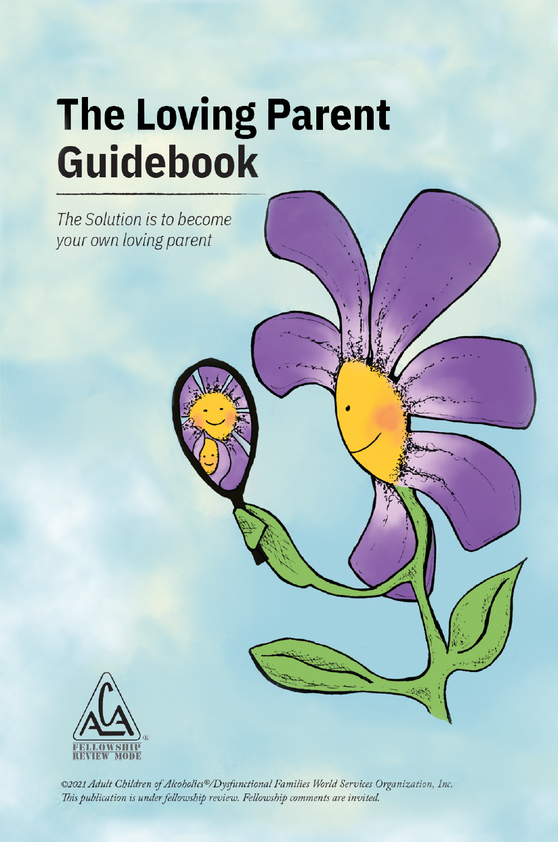 | The Loving Parent Guidebook. The Solution is to become your own loving parent. An image of a daisy flower, representing the inner loving parent, holding a handheld mirror. The flower looks into the mirror and its smiling face and a small flower bud, representing the inner child, are reflected back. This represents the process of becoming our own loving parent and reclaiming the inner child. A logo of Adult Children of Alcoholics is comprised of the acronym, A C A written inside a triangle. The registered trademark symbol, R inside the circle, appears to the right of the logo. Below the triangle the words Fellowship Review Mode appear. ©2021 Adult Children of Alcoholics®/Dysfunctional Families World Services Organization, Inc. This publication is under fellowship review. Fellowship comments are invited.
2 | Title page | 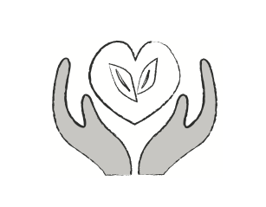 | An icon with gray hands cupping a line drawing of a heart. Within the heart are two leaves.
3 | i (Title page) |  | A logo of Adult Children of Alcoholics, comprised of the acronym, A C A, written inside a triangle. The registered trademark symbol appears to the right of the logo. Below the triangle appear the words Fellowship Review Mode.
3a | 0 | 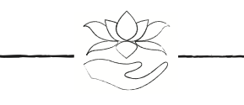 | A cupped hand holds a lotus flower above the serenity prayer.
4 | 4 | 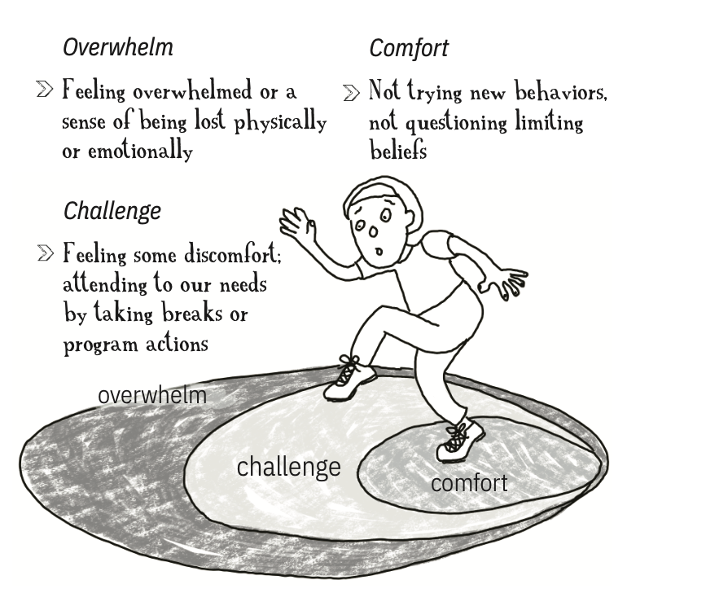 | A line drawing of an adult child standing in a circle with three shaded zones marked comfort, challenge, and overwhelm. The adult child has one foot in the comfort zone and is stepping into the challenge zone. Above the adult child is text describing the three zones. The outermost zone is labeled "Overwhelm. Feeling overwhelmed or a sense of being lost physically or emotionally." The text to the right is labeled "Comfort. Not trying new behaviors, not questioning limiting beliefs." The bottom left is labeled "Challenge. Feeling some discomfort; attending to our needs by taking breaks or program actions."
5 | 5 | 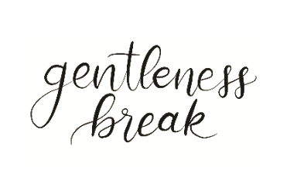 | Text that reads "Gentleness Break."
6 | i(5) | 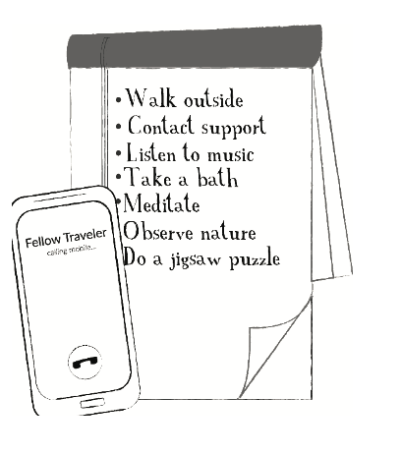 | Clip art of a smartphone with Fellow Traveler on the screen, representing picking up the telephone and a notepad with text bullets reading "Walk outside, contact support, listen to music, take a bath, meditate, observe nature, do a jigsaw puzzle."
7 | 7 | 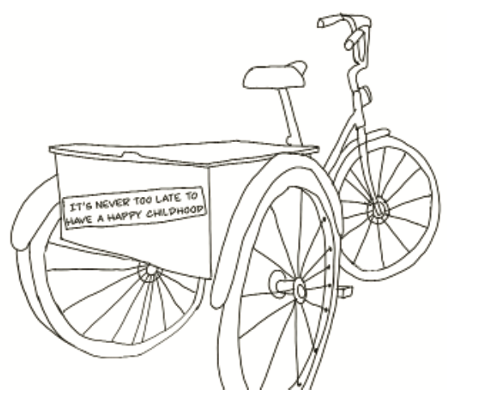 | A line drawing of a tricycle with a storage box on the back. A bumper sticker on the back of the box reads, "It's never too late to have a happy childhood."
8 | i(7) |  | A cupped hand holds a lotus flower.
9 | 8 | 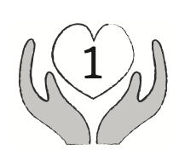 | An icon of gray hands holding a heart with the number 1 inside to indicate chapter 1.
10 | 10 | 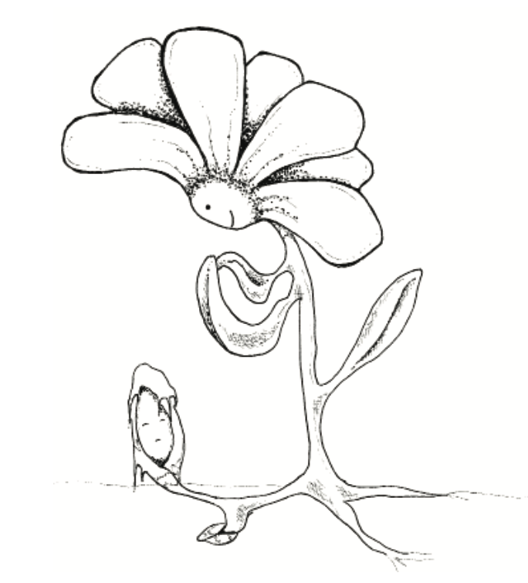 | A flower with its leaves in an embrace gazes lower on its stem toward the inner child emerging with its petals partially hiding its face.
11 | 11 | 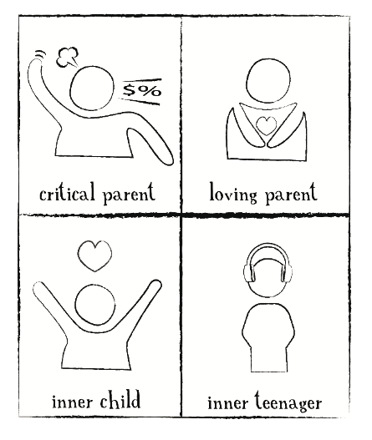 | Chart with four boxes. Box 1 is labled critical parent and contains a person with steam coming from their head. Box 2 is labeled loving parent and contains a person with their arms hugging a heart. Box 3 is labeled inner child and shows a child with arms stretched up for a hug. A heart sits over their head. Box 4 is labeled inner teenager and shows a person wearing headphones.
12 | 12 | 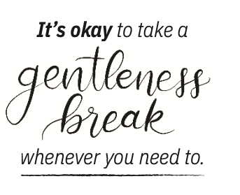 | Text that reads, "It's okay to take a gentleness break whenever you need to."
13 | 14 | 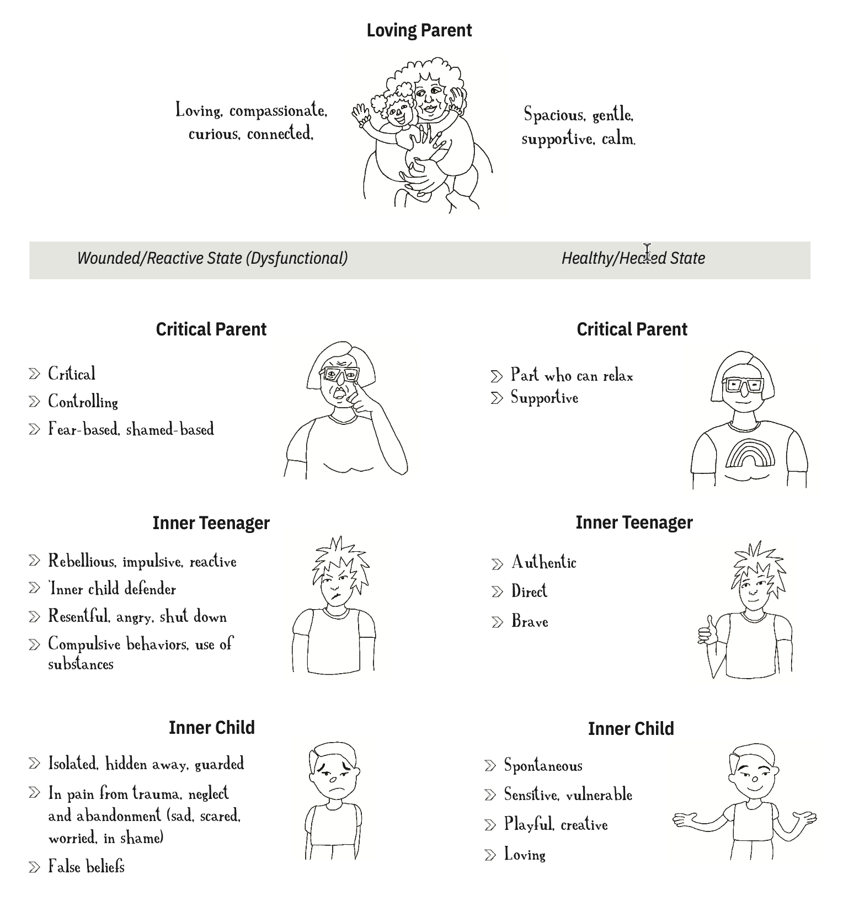 | Inner family chart. A line drawing of an inner loving parent at the top holding an inner child who smiles with outstretched arms. On the left are the words loving, compassionate, curious, and connected. The words spacious, gentle, supportive, and calm are on the right. Below that, a gray line stretches across the chart with two columns. The left column is labeled "Wounded/reactive state (dysfunctional)," and the right column is labeled "Healthy/Healed State." Underneath is an image of a critical parent frowning with their finger pointed toward the viewer. The words on the left are critical, controlling, fear-based, and shame-based. On the right is an image of a critical parent with a serene look on their face with the words part who can relax, supportive. The left column of the next row shows an inner teenager with spiky hair and a frown. To the left of this image are the words rebellious, impulsive, reactive, inner child defender, resentful, angry, shut down, compulsive behaviors, and use of substances. In the right column, the inner teenager has spiky hair and gives a thumb's up sign to say "ok" with a serene look on their face. The left column of the last row shows a sad inner child with arms tightly at their side, and the words isolate, hidden away, guarded, in pain from trauma, neglect, abandonment (sad, scared, worried, in shame), false beliefs. In the right column, the inner child smiles with their arms stretched wide, and the words read spontaneous, sensitive, vulnerable, playful, creative, and loving.
14 | 16 | 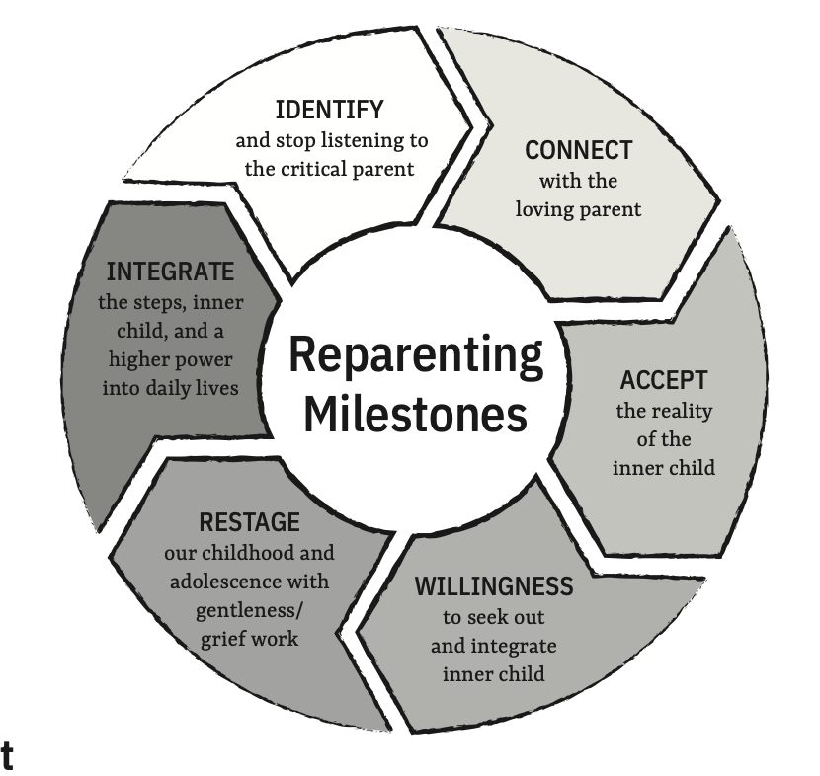 | Reparenting Milestones flowchart. Text in the middle with arrows filled with text going around in a circle. Text arrows read: IDENTIFY and stop listening to the critical parent. CONNECT with the loving parent. ACCEPT the reality of the inner child. WILLINGNESS to seek out and integrate inner child. RESTAGE our childhood and adolescence with gentleness/grief work. INTEGRATE the steps, inner child, and a higher power into daily lives.
15 | (i)16 | 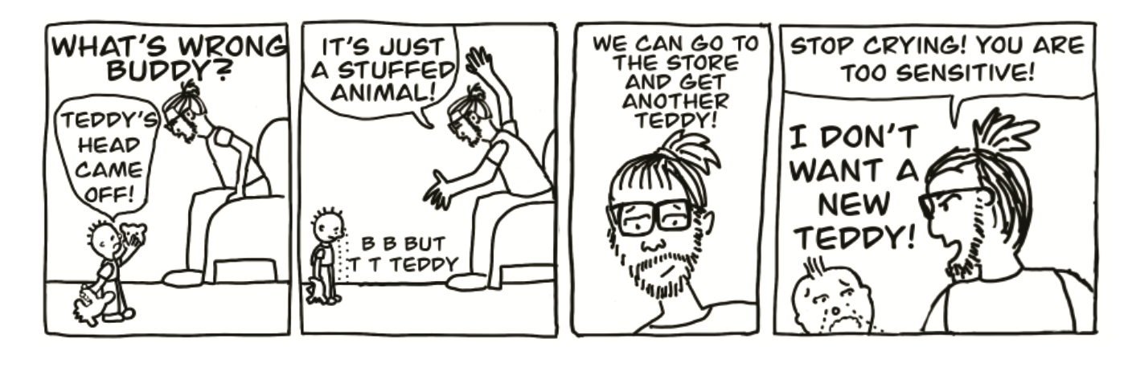 | 4 panel comic shows child and parent with text: Panel 1: Crying young child approaches the parent holding a stuffed animal whose head has come off. The parent asks, "What's Wrong Buddy?" The child says, "Teddy's head came off!" Panel 2: The parent raises their arms in exasperation and says, "It's just a stuffed animal!" The child cries and looks at the ground saying, "B B But T T Teddy." Panel 3: The parent says, "We can go to the store and get another teddy!" Panel 4: The child cries and says, "I don't want a new teddy!" The parent says, "Stop Crying! You are too sensitive!" The child looks at the parent with a look of despair and cries.
16 | 17 | 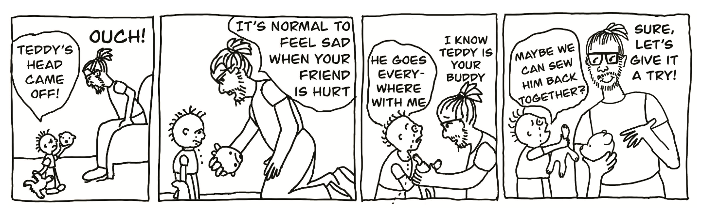 | 4 panel comic shows crying young child and parent with text: Panel 1: Child says, "Teddy's Head came off!" The parent leans toward the child and responds, "Ouch!" Panel 2. "The parent gets on the floor next to the child and cups the stuffed animal's head and says, "It's normal to feel sad when your friend is hurt." 3 The child looks at the parent and says, "He goes everywhere with me." The parent looks at the child and says, "I know, Teddy is your buddy." Panel 4. The child holds the stuffed animal toward the parent and says: "Maybe we can sew him back together?" The parent says, "Sure, let's give it a try!"
17 | 20 |  | A cupped hand holds a lotus flower above the words Affirmation / Meditation
18 | 21 | 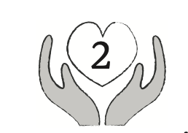 | gray hand icon holding a heart with the number 2 inside to indicate chapter 2.
19 | (i)21 | 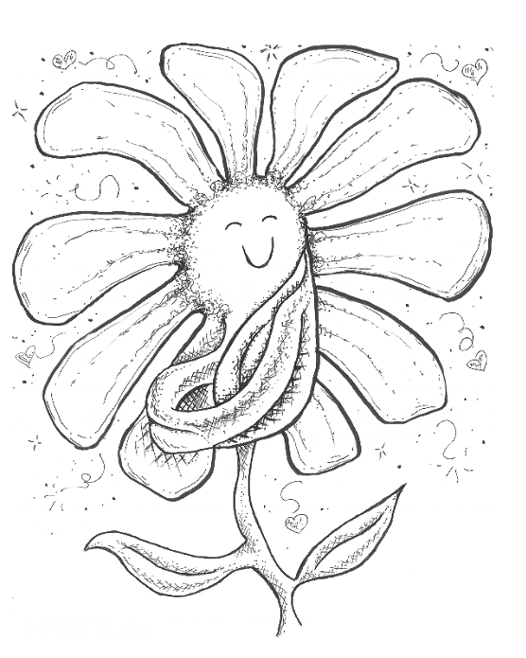 | A smiling daisy with its eyes closed has two leaves wrapped across its stem like a hug.
20 | 24 | 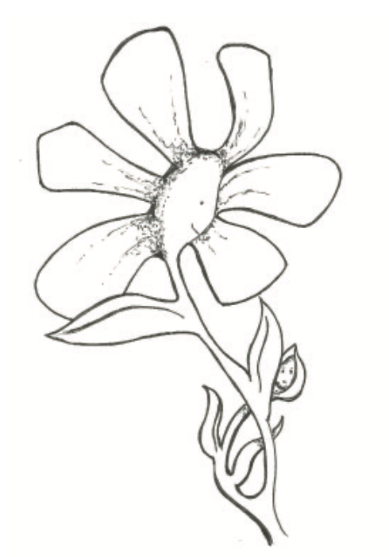 | A daisy wears a loving, warm expression as it gazes at the hesitant inner child hidden partially behind a leaf.
21 | 25 | 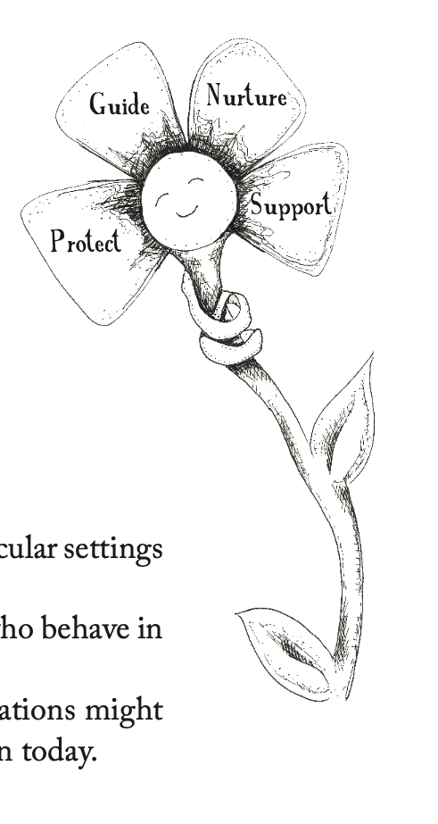 | Smiling flower with its eyes closed, with a leaf wrapped around its stem like a hug. Each of the flower's four petals has the needs an inner loving parent meets - Protect, Guide, Nurture, and Support.
22 | 30 |  | A cupped hand holds a lotus flower next to an Affirmation / Meditation
23 | 31 | 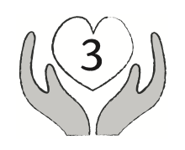 | Gray hands holding a heart with the number 3 inside to indicate chapter 3.
24 | 34 | 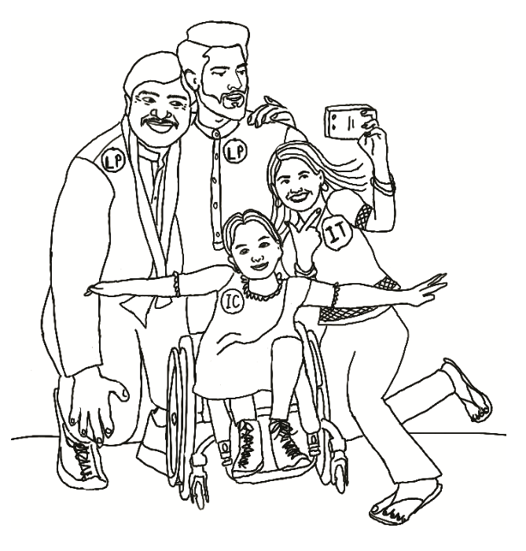 | Healthy family illustration. Two smiling parents stand behind a smiling inner child in a wheelchair holding their arms out like a bird. A smiling, playful inner teenager poses behind her and in front of the parents holding a phone and taking a selfie.
25 | 37 |  | A cupped hand holds a lotus flower next to an Affirmation / Meditation
26 | 38 | 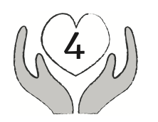 | Gray hands holding a heart with the number 4 inside to indicate chapter 4.
27 | (i)38 | 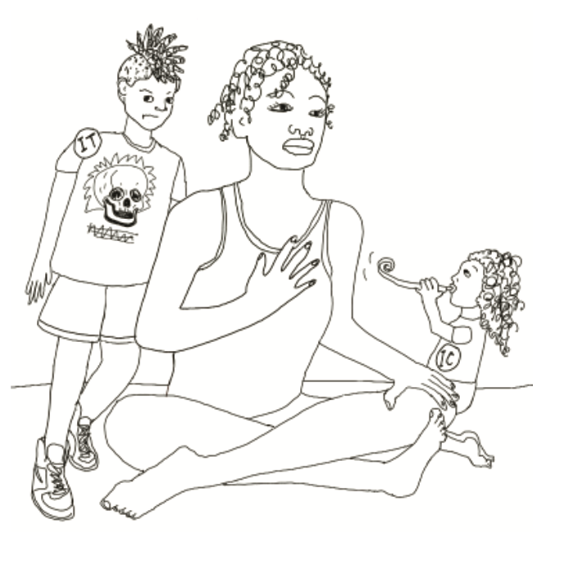 | An adult child sits crosslegged, meditating with a hand on their heart, looking serene. Behind them, an inner teenager stands with a look of annoyance. An inner child kneels near the adult child blowing a party noisemaker.
28 | 39 | 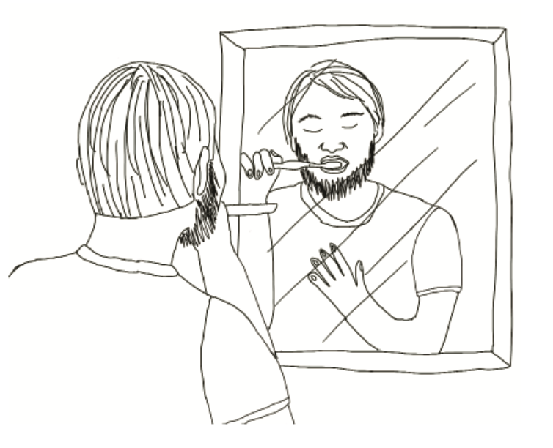 | An illustration of an adult child reflected in a mirror as they practice mindfulness while brushing their teeth. Their eyes are closed, and they have one hand on their heart.
29 | 41 | 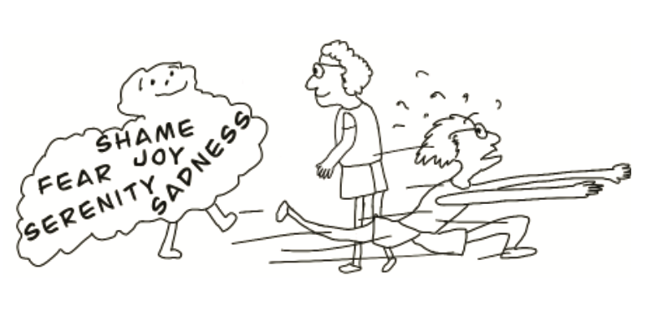 | A smiling blob with the words shame, fear, joy, serenity, and sadness walks toward an adult child running in the opposite direction. The adult child turns to face the blob with a look of openness.
30 | 45 |  | A cupped hand holds a lotus flower above the words Affirmation / Meditation
31 | 46 | 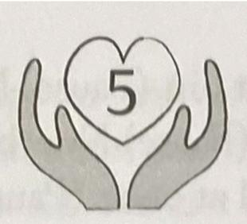 | Gray hands holding a heart with the number 5 inside to indicate chapter 5.
32 | 46 | 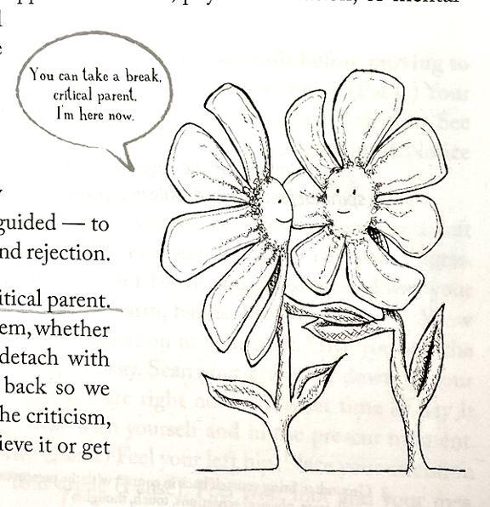 | Two flowers talking: The inner loving parent flower smiles and says: You can take a break, critical parent. I'm here now.
33 | 48 | 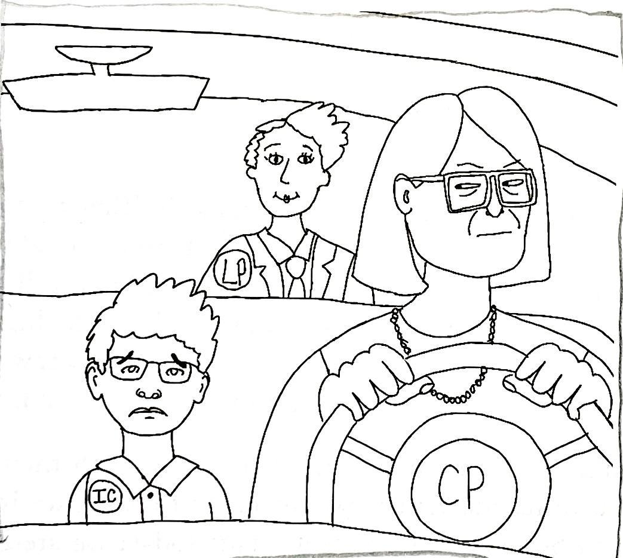 | Three people in a car. Critical parent is driving. The inner child is sad and in the front passenger seat. Loving Parent is in the back seat.
34 | 56 | 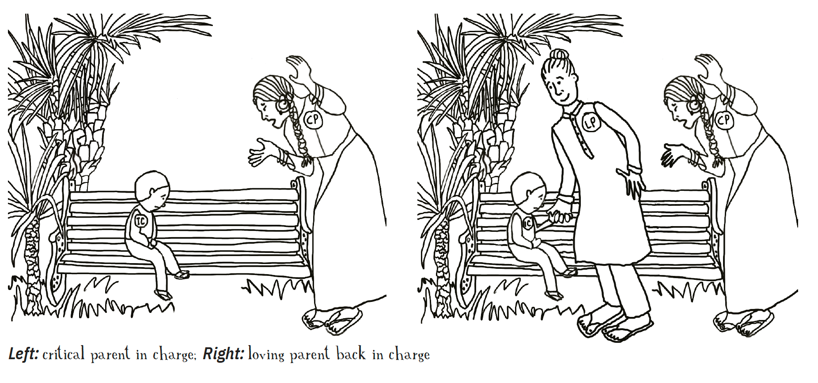 | First image: an Inner Child sitting on an outdoor bench with a Critical Parent raising hands and saying something. Second image: an Inner Child seated on an outdoor bench with a Critical Parent raising hands and saying something but now with a Loving Parent in between reaching out to the Inner Child.
35 | 58 | 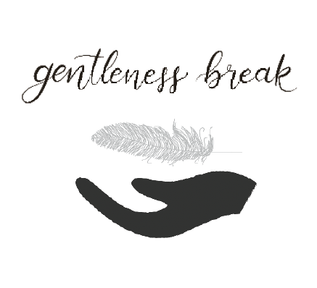 | Black hands cupping a feather with the words "Gentleness Break" over them.
36 | 60 | 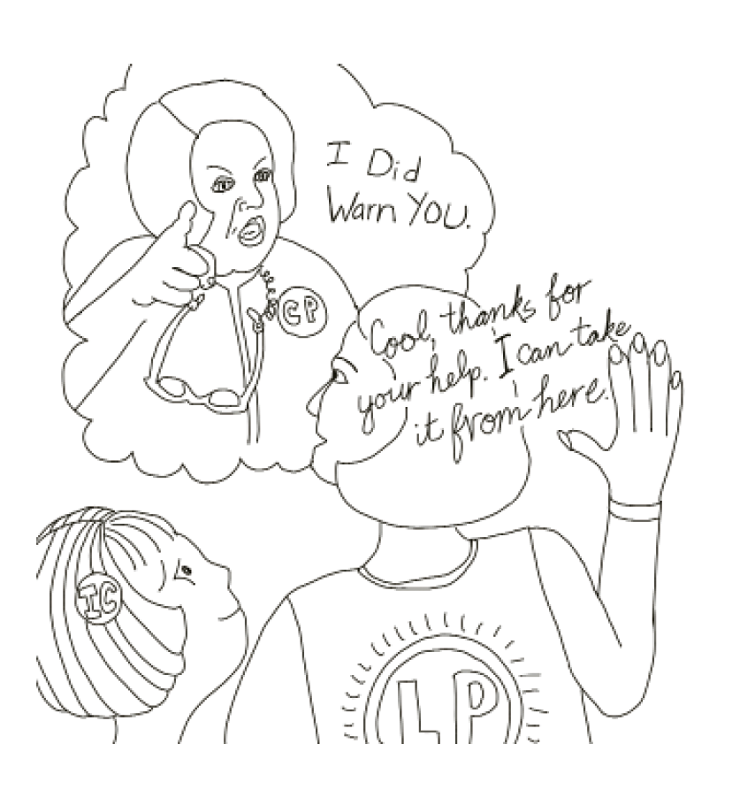 | An inner child with short, straight hair gazes at their loving parent, whose back is to the viewer. The loving parent holds up their right hand to set a boundary with the critical inner parent. The critical parent is in a thought bubble looking at the inner loving parent, pointing their finger sternly. The critical parent says, "I did warn you." The inner loving parent replies, "Cool, thanks for your help. I can take it from here."
37 | 61 | 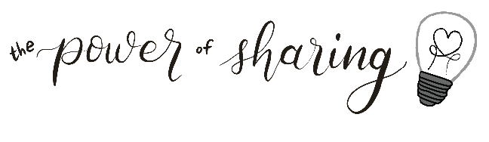 | Text that reads "the power of sharing" with illustration of a lightbulb to the right of it. Inside the lightbulb the filament forms a heart.
38 | 62 |  | A cupped hand holds a lotus flower above the words Affirmation / Meditation
39 | 63 | 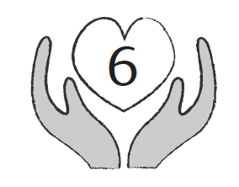 | Gray hands holding a heart with the number 6 inside to indicate chapter 6.
40 | (i)63 | 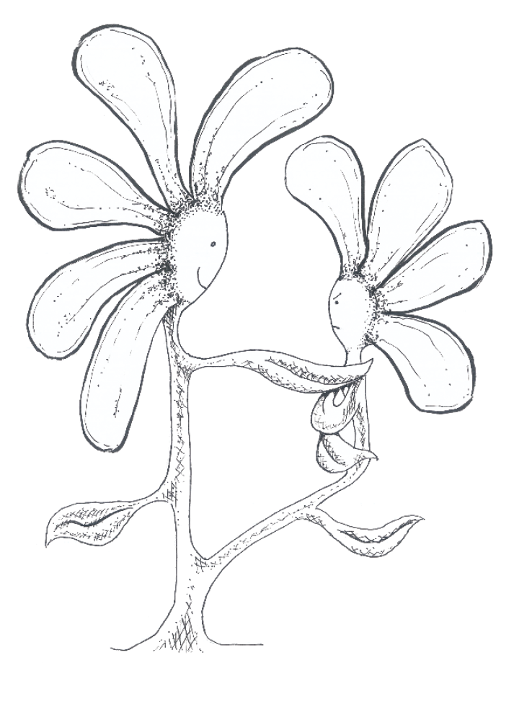 | Large flower props up and holds hands with small flower
41 | 68 |  | Text that reads "the power of sharing" with illustration of a lightbulb to the right of it. Inside the lightbulb the filament forms a heart.
42 | 71 | 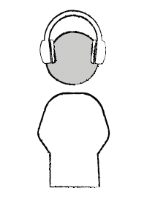 | An icon of a torso with a gray head with headphones on to represent the inner teenager.
43 | 72 |  | Text that reads "Gentleness Break."
43 | 75 |  | A cupped hand holds a lotus flower above the words Affirmation / Meditation
44 | 76 | 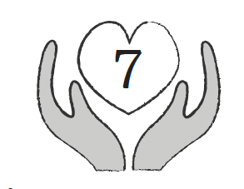 | Gray hands holding a heart with the number 7 inside to indicate chapter 7.
45 | (i)76 | 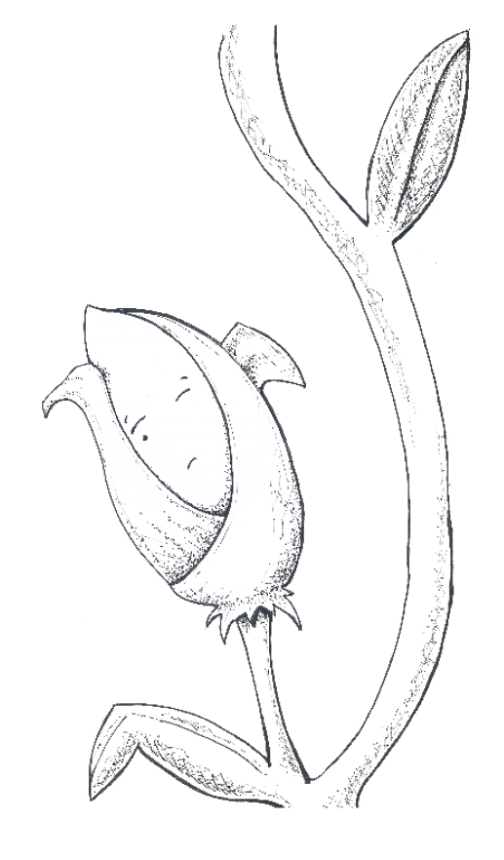 | Line drawing of a flower bud opening its eyes to represent the inner child.
46 | 77 |  | Text that reads, "It's okay to take a gentleness break whenever you need to."
47 | 80 |  | Text that reads "the power of sharing" with an illustration of a lightbulb to the right of it. Inside the lightbulb, the filament forms a heart.
48 | 81 | 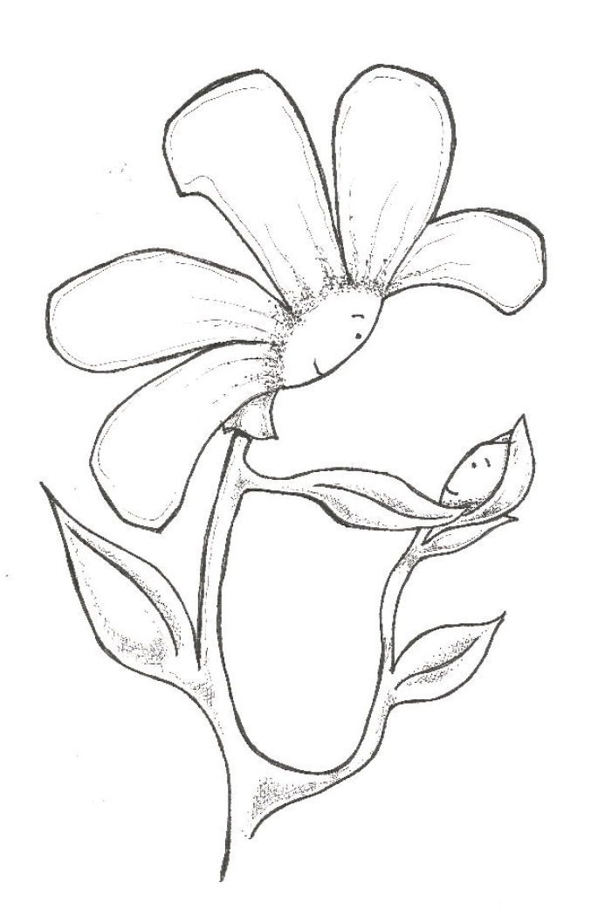 | A loving Parent flower gazes lovingly toward the inner child flower bud and reaches out with a leaf.
49 | 82 |  | Text that reads "Gentleness Break."
50 | 83 | 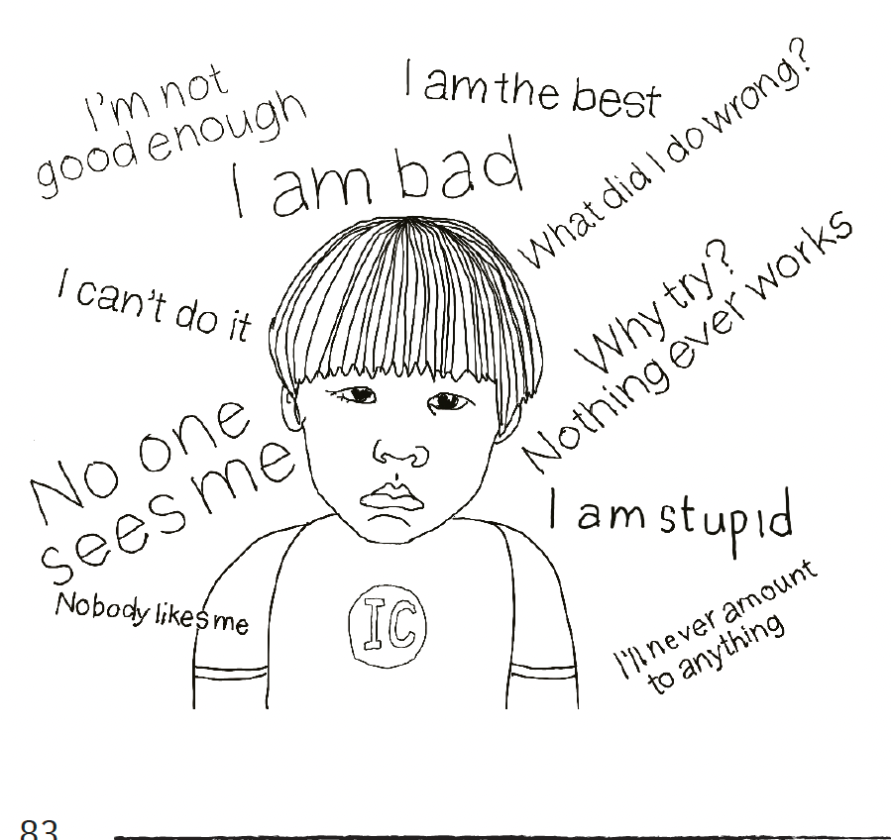 | An illustration of a sad inner child wearing a short bowl haircut and a t-shirt. False beliefs surround the inner child. The false beliefs from left to right read “Nobody likes me,” “No one sees me,” “I can’t do it,” “I’m not good enough,” “I am bad,” “I am the best,” “What did I do wrong?”, “Why try? Nothing ever works”, “I am stupid,” and “I’ll never amount to anything.”
51 | 85 |  | Text that reads "the power of sharing" with illustration of a lightbulb to the right of it. Inside the lightbulb the filament forms a heart.
52 | 87 |  | A cupped hand holds a lotus flower above the words Affirmation / Meditation
53 | 88 | 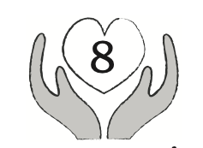 | Gray hands holding a heart with the number 8 inside to indicate chapter 8.
54 | (i)88 | 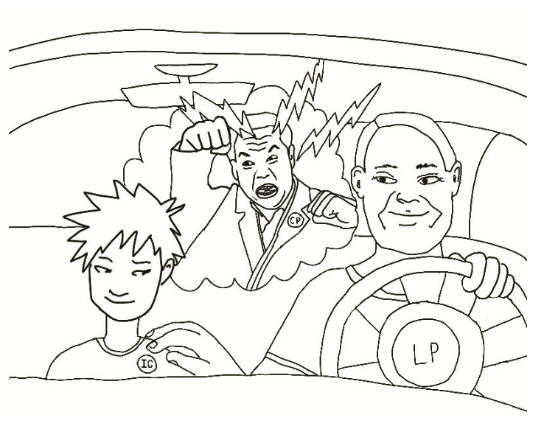 | Three people in a car. The loving parent's face is calm, and they have a hand on the steering wheel. The Loving Parent's other hand comforts the inner child's shoulder in the passenger seat, who has a slight smile on their face. The critical parent is in the backseat, with an angry expression and lightning bolts around their head, one hand raised in anger.
55 | 89 | 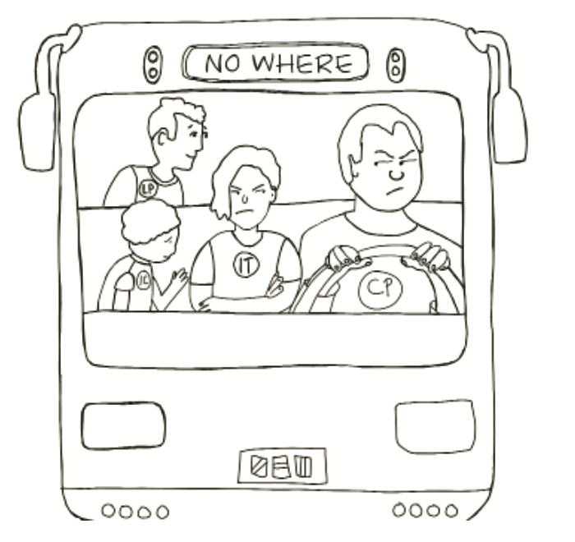 | Four people sit on a bus whose destination is marked Nowhere. A critical parent drives the bus, scowling. A frowning inner teenager sits beside the critical parent with arms crossed across their chest. The sad inner child is turned to face the inner teenager and reaches for the inner teenager. The loving parent is in the back of the bus, behind the inner child, looking out the opposite window.
56 | 93 |  | A cupped hand holds a lotus flower above the words Affirmation / Meditation
56a | 94 | 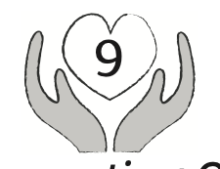 | An icon of gray hands holding a heart with the number 9 inside to indicate chapter 9.
57 | 96 | 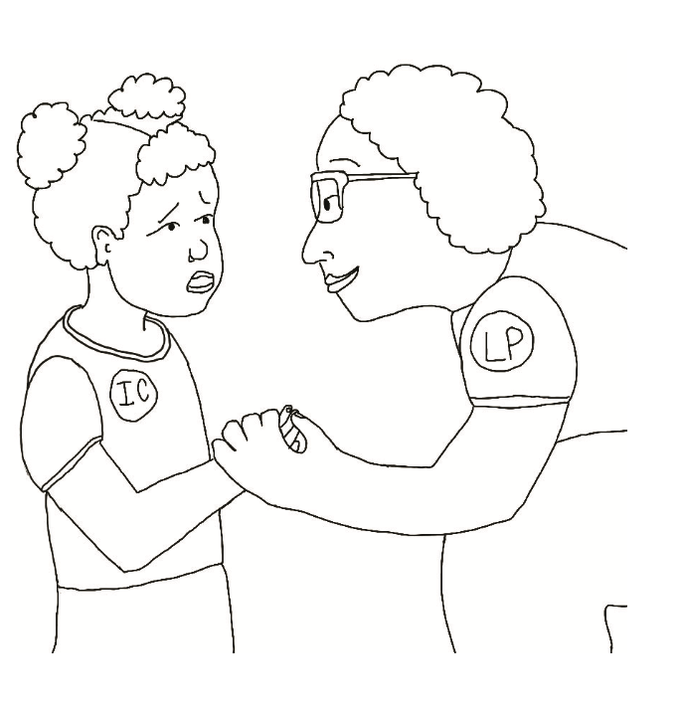 | An inner-loving parent is tending to and caring for their inner child. The inner loving parent is crouched down to the inner child's eye level and has a warm smile on their face. The inner loving parent is looking into the eyes of a sad inner child and holding the inner child's hand. The inner child is on the left, and the inner loving parent is on the right.
57a | 100 |  | A cupped hand holds a lotus flower above the words Affirmation / Meditation
58 | (i)100 | 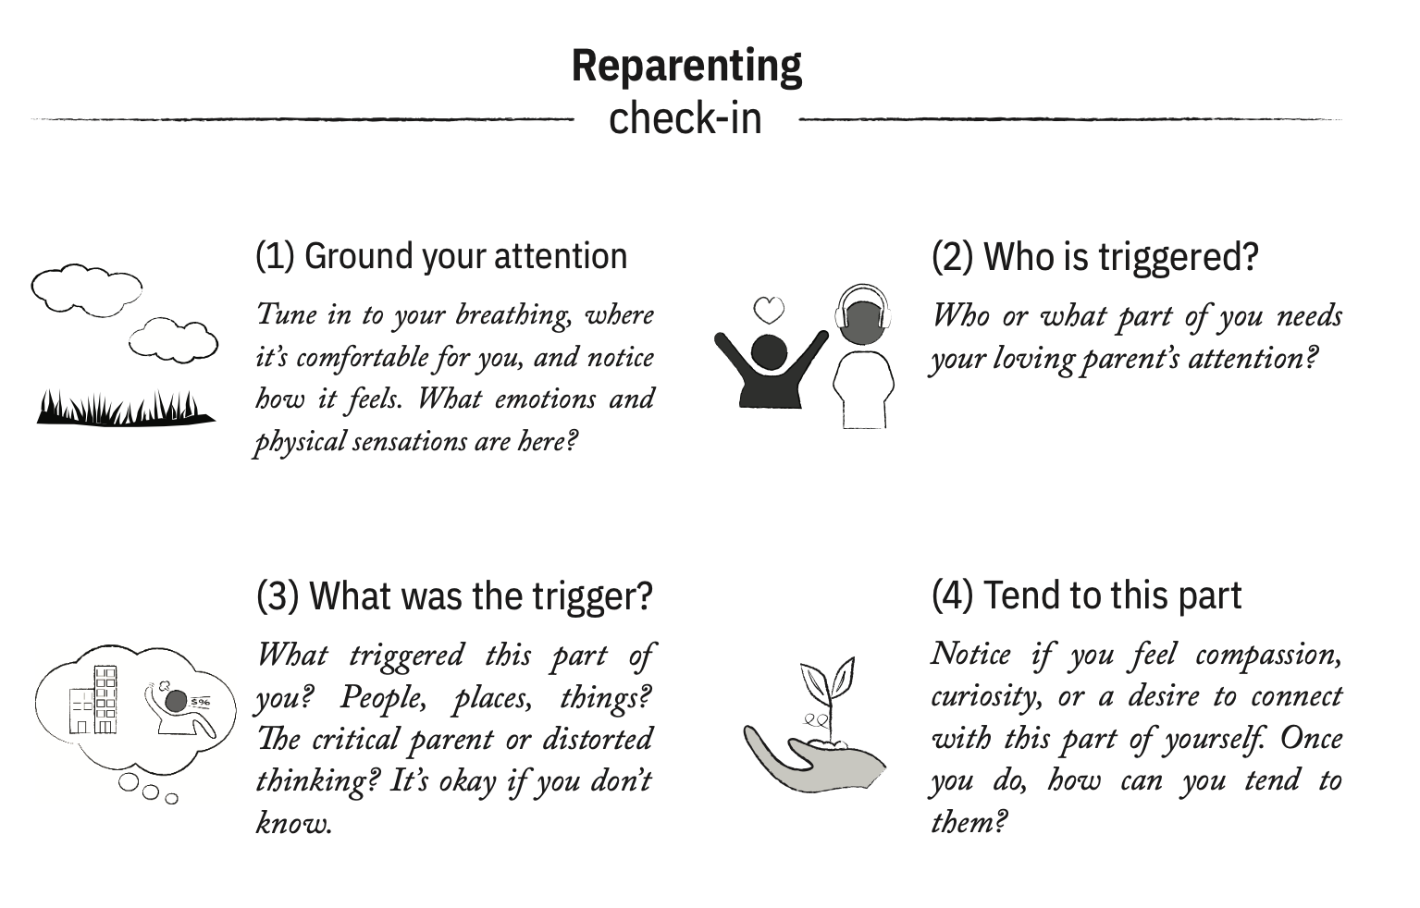 | A Reparenting Check-in list 1. Ground your attention. Tune in to your breathing, where it’s comfortable for you, and notice how it feels. What emotions and physical sensations are here?  2. Who is triggered? Who or what part of you needs your loving parent’s attention? 3. What was the trigger? What triggered this part of you? People, places, things? The critical parent or distorted thinking? It’s okay if you don’t know. 4. Tend to this part. Notice if you feel compassion, curiosity, or a desire to connect with this part of yourself. Once you do, how can you tend to them?  To the left of number 1 is an illustration of a field with clouds in the sky. To the left of number 2 is an illustration of the inner child and inner teenager. The inner child has arms stretched out above their head and a heart above them. The inner teenager wears headphones. To the left of number 3 is a thought bubble. Inside the bubble is an icon of a person with their fist up yelling at some buildings. To the left of number 4 is a gray palm with a sprout in hand.
59 | 101 | 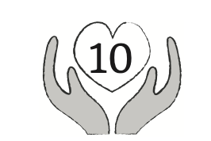 | An icon of gray hands holding a heart with the number 10 inside to indicate chapter 10.
60 | 102 | 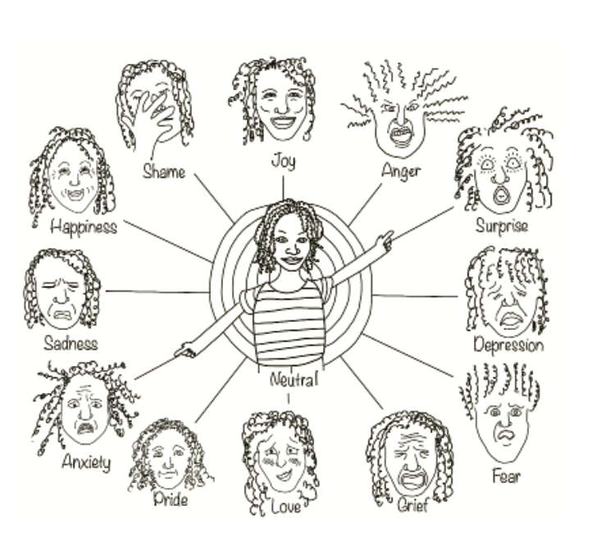 | Drawing of a face surrounded by 12 different facial expressions. The central figure is labeled as neutral and points at a wide-eyed face labeled surprise and on the opposite side to a face with furrowed brow labeled anxiety. Other expressions shown are joy, anger, depression, fear, grief, love, pride, sadness, happiness, and shame.
61 | 103 | 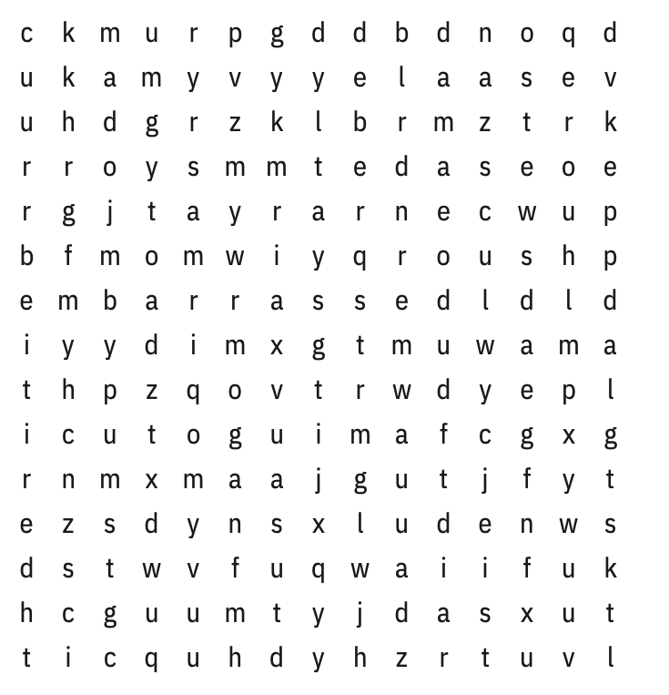 | Drawing of a face surrounded by 12 different facial expressions. The central figure is labeled as neutral and points at a wide-eyed face labeled surprise and on the opposite side to a face with furrowed brow labeled anxiety. Other expressions shown are joy, anger, depression, fear, grief, love, pride, sadness, happiness, and shame.
62 | 106 | 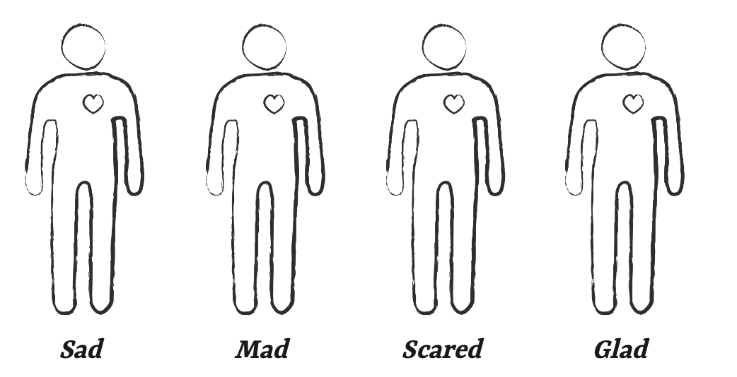 | A line drawing of four human body outlines to color in. Each outline has a word below it: sad, mad, scared, glad.
63 | 109 |  | A word search puzzle of need words.
64 | 110 |  | A word search puzzle of need words.
65 | 112 | 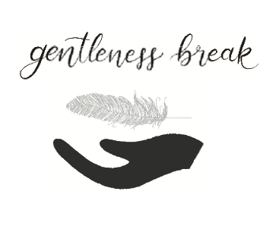 | A word search puzzle of need words.
66 | 117 |  | A cupped hand holds a lotus flower above the words Affirmation / Meditation
67 | 118 | 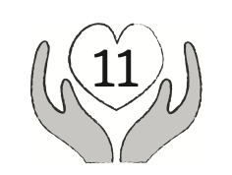 | An icon of gray hands holding a heart with the number 11 inside to indicate chapter 11.
68 | (i)118 | 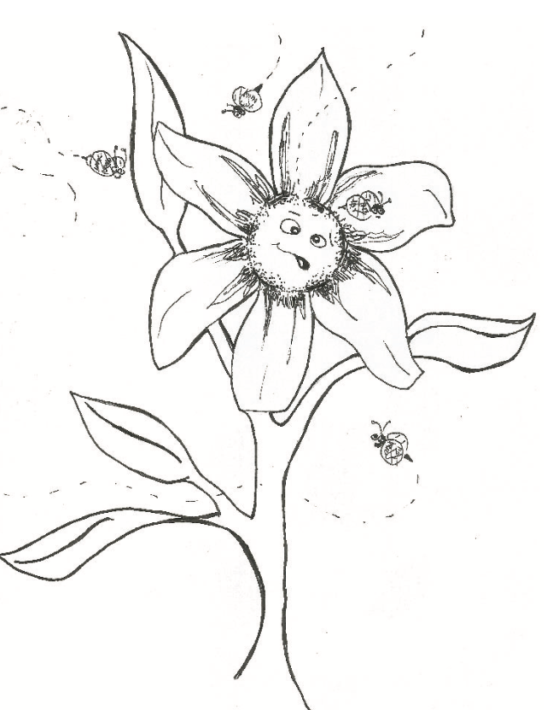 | Bees buzz around the head of a flower. The flower's face shows confusion and disorientation, representing distorted thinking.
69 | 129 |  | Bees buzz around the head of a flower. The flower's face shows confusion and disorientation, representing distorted thinking.
70 | 130 | 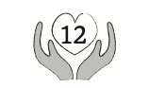 | An icon of gray hands holding a heart with the number 12 inside to indicate chapter 12.
71 | (i)130 | 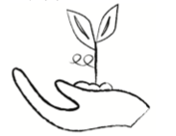 | A cupped hand with a seedling sprouting from the hand. The seedling has two leaves and swirl twig coming out the left side. Below this image reads, "tend to: care for. look after. give one's attention to."
72 | 131 | 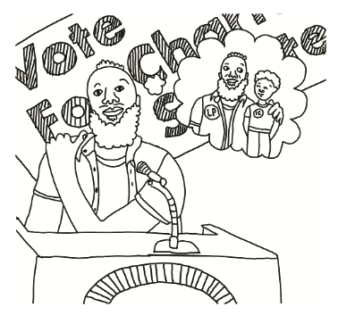 | A bearded person wearing a short-sleeved button-down opened over a t-shirt stands at a podium giving a speech. The person's hand is on their shoulder, representing comforting touch for the inner child. A banner reading "Vote for Change" is behind the person. A thought bubble is to the person's right. It shows the person with an arm around their inner child.
73 | 134 | 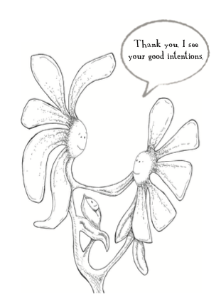 | Three-headed flower as self with Loving Parent touching Inner Teen with a leaf and saying, "Thank you. I saw your good intentions." The Inner Child, as the flower bud, looks on lovingly.
74 | 138 | 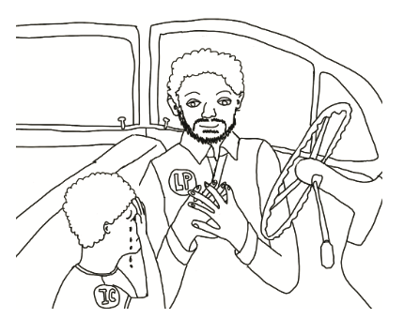 | An illustration of a Loving Parent and Inner Child sitting together in the front seat of a car. The Inner Child is crying and covers their hands with their eyes. The Loving Parent sits and listens to the Inner Child with their hands over their heart.
75 | (i)138 |  | A cupped hand holds a lotus flower above the words Affirmation / Meditation
76 | 139 | 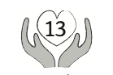 | An icon of gray hands holding a heart with the number 13 inside to indicate chapter 13.
77 | 143 | 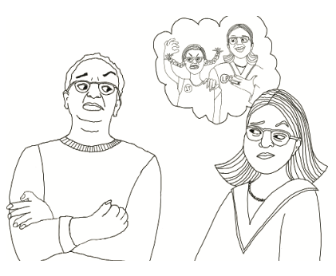 | A short-haired person, arms crossed, looks sideways at a slightly smaller person with long hair, who returns a sideways look. Both have eyebrows raised and appear to be in conflict. The smaller person has a thought bubble with a smiling, Loving Parent standing behind the Inner Teenager who raises a clenched hand, frowns, and bars their teeth. One of the Loving Parent's hands rests on the Inner Teenager's shoulder, and the other is on their own upper chest as if to comfort and support.
78 | 144 | 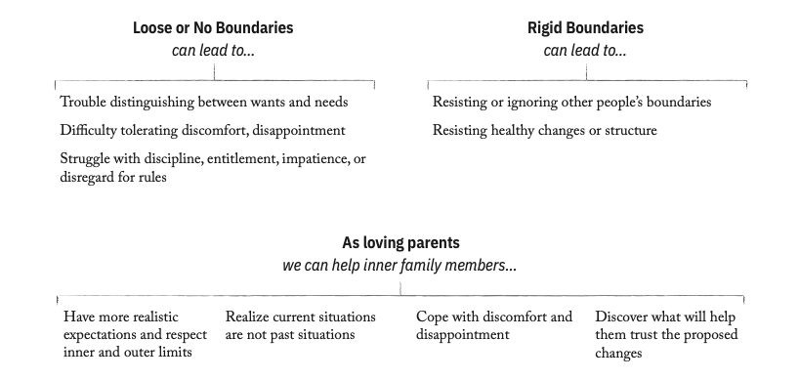 | Three blocks of bulleted text are arranged in two rows. There are two blocks of text on the top row and one on the bottom row. The top right block says, "Rigid boundaries can lead to…" Resisting or ignoring other people's boundaries. Resisting healthy changes or structure. The top left says, "Loose or no boundaries can lead to…" Trouble distinguishing between wants and needs. Difficulty tolerating discomfort, and disappointment. Struggle with discipline, entitlement, impatience, or disregard for the rules. The bottom blocks of text says, "As loving parents, we can help inner family members…" Have more realistic expectations and respect inner and outer limits. Realize current situations are not past situations. Cope with discomfort and disappointment. Discover what will help them trust the proposed changes.
79 | 145 |  | A cupped hand holds a lotus flower above the words Affirmation / Meditation
80 | 146 | 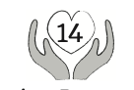 | An icon of gray hands holding a heart with the number 14 inside to indicate chapter 14.
81 | 147 |  | Text that reads "the power of sharing" with illustration of a lightbulb to the right of it. Inside the lightbulb the filament forms a heart.
82 | 148 | 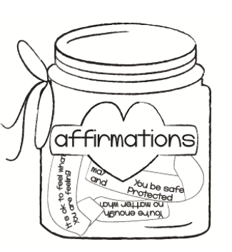 | An illustration of a jar with a string tied around the top into a bow hanging off the left side. The jar is labeled with the word affirmations. The affirmations in the jar read, "its ok to feel what you are feeling.", "You're enough no matter what.", and "May you be safe and protected."
83 | 149 | 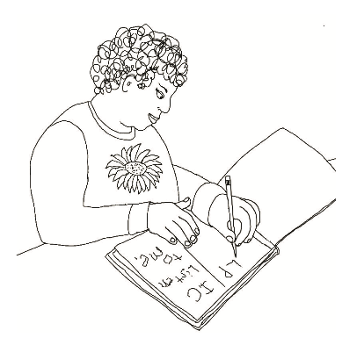 | A line drawing shows a person with short curly hair wearing a long-sleeved shirt with a sunflower in the center practicing non-dominant handwriting. The person writes in their journal with their lefthand. In the journal are two columns. The columns are labeled. The left column is LP (Loving Parent), and the right is IC (Inner Child). The text in the Inner Child column reads, “Listen to me.”
84 | 155 |  | A cupped hand holds a lotus flower above the words Affirmation / Meditation
85 | 156 | 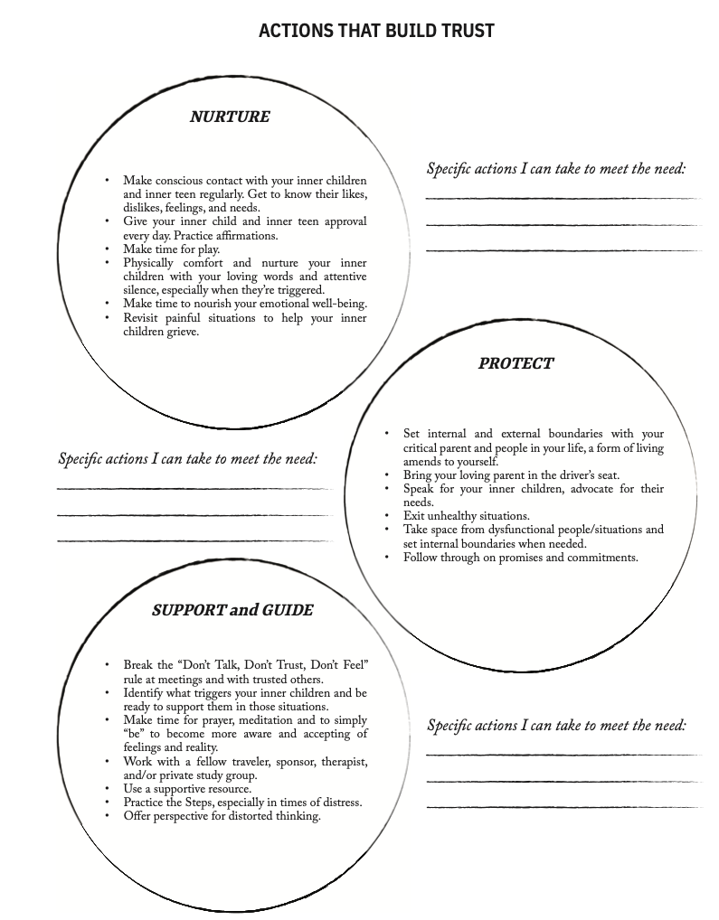 | An illustration entitled "Actions That Build Trust." It contains three circles labeled Nurture, Protect, Support and Guide. Next to each circle are blank lines with the heading "Actions I Can Take to Meet the Need," where the reader can write their responses.
86 | 157 | 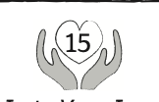 | An icon of gray hands holding a heart with the number 15 inside to indicate chapter 15.
87 | 158 | 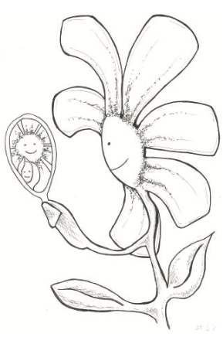 | A smiling flower representing the self holds a mirror with one of its leaves and peers inside the mirror to see itself reflected as a smiling Loving Parent and Inner Child.
88 | 162 |  | A cupped hand holds a lotus flower above the words Affirmation / Meditation
89 | 163 | 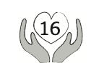 | An icon of gray hands holding a heart with the number 16 inside to indicate chapter 16.
92 | 171 |  | A cupped hand holds a lotus flower above the words Affirmation / Meditation
93 | 172 | 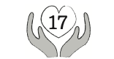 | An icon of gray hands holding a heart with the number 17 inside to indicate chapter 17.
94 | 174 |  | A cupped hand holds a lotus flower above the words Affirmation / Meditation
95 | 175 | 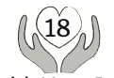 | An icon of gray hands holding a heart with the number 18 inside to indicate chapter 18.
96 | (i)175 | 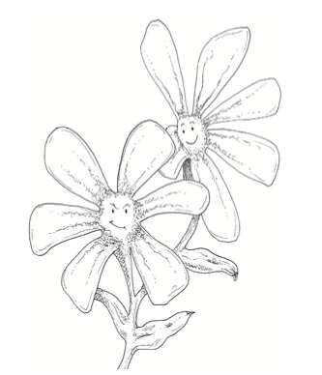 | A flower with heads. One has a smiling expression representing the loving parent, and the other smirks, representing the inner teenager.
99 | 185 |  | A cupped hand holds a lotus flower above the words Affirmation / Meditation
100 | 186 | 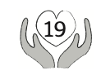 | An icon of gray hands holding a heart with the number 19 inside to indicate chapter 19.
101 | 190 | 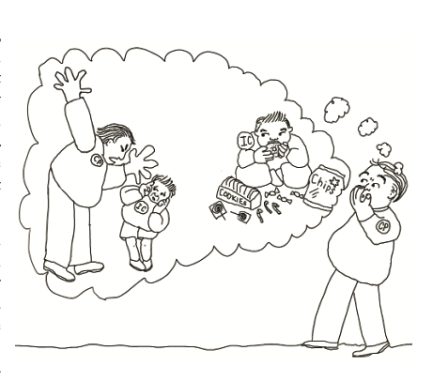 | An illustration of a critical parent realizing their inner child is experiencing pain, and their efforts are making it worse. The critical parent has a thought bubble to their left. In the thought bubble, the critical parent yells at their inner child as the inner child crouches in fear and covers their ears. Also, in the thought bubble, the inner child copes with their fear by eating a donut and other sweets. Surrounding the inner child is lollipops, cookies, candy canes, and chips.
102 | 193 |  | A cupped hand holds a lotus flower above the words Affirmation / Meditation
103 | 194 | 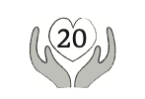 | An icon of gray hands holding a heart with the number 20 inside to indicate chapter 20.
104 | 195 | 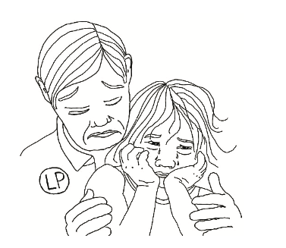 | An illustration of an inner loving parent comforting a crying inner child who leans their back against the loving parent. The inner loving parent comforts the child, holding their arms as the child cups their own face. Tears stream down the inner child's cheeks.
105 | (i)195 |  | Text that reads "the power of sharing" with illustration of a lightbulb to the right of it. Inside the lightbulb the filament forms a heart.
106 | 196 | 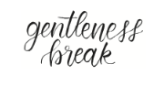 | Text that reads "Gentleness break."
107 | 199 | 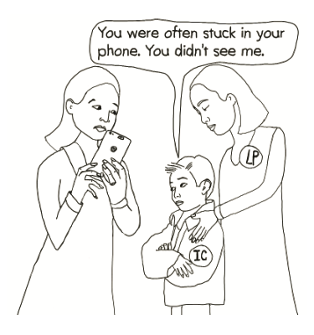 | An illustration of an inner child standing with their arms crossed looking at their caregiver who is holding and using a smartphone. The caregiver looks at the inner child with one eye on their phone. The inner child's inner loving parent stands behind them with their hands on the inner child's shoulders. The inner loving parent's eyes are closed, and their face is serene and compassionate. The inner child says, "You were often stuck in your phone. You didn't see me.'" This scene represents revisiting a past situation with your inner child and supporting them to stand up to their caregiver if they want.
108 | 200 |  | Text that reads "Gentleness break."
109 | 202 |  | Text that reads "Gentleness break."
110 | 203 |  | A cupped hand holds a lotus flower above the words Affirmation / Meditation
111 | 204 | 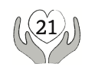 | An icon of gray hands holding a heart with the number 21 inside to indicate chapter 21.
112 | (i)204 | 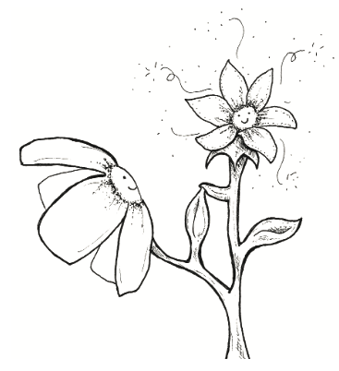 | Two flowers on the same stem represent a Loving Parent and Inner Child. They give each other a high-five with their leaves.
113 | 207 |  | Text that reads "the power of sharing" with illustration of a lightbulb to the right of it. Inside the lightbulb the filament forms a heart.
114 | (i)207 | 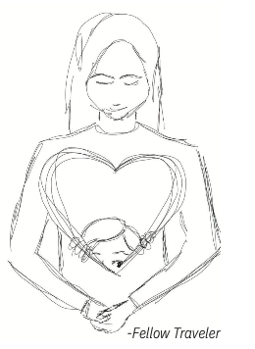 | A fellow traveler illustration of an inner loving parent with a large heart drawing across their chest. At the bottom of the heart, an inner child peaks out.
115 | 209 | 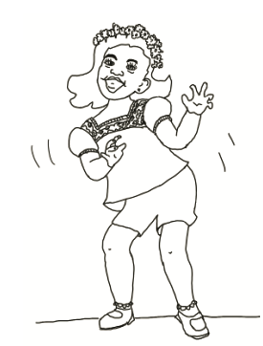 | An illustration of an inner child dancing and having fun. The inner child wears a lei crown with hair down to their shoulders. They grin and move their arms to the left. They wear a blouse and shorts. They also have socks and shoes.
116 | 210 |  | A cupped hand holds a lotus flower above the words Affirmation / Meditation
117 | 211 | 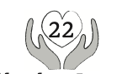 | An icon of gray hands holding a heart with the number 22 inside to indicate chapter 22.
118 | (i)211 | 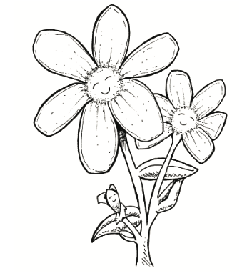 | Three smiling flower heads represent the inner loving parent, inner teenager, and inner child.
119 | 215 | 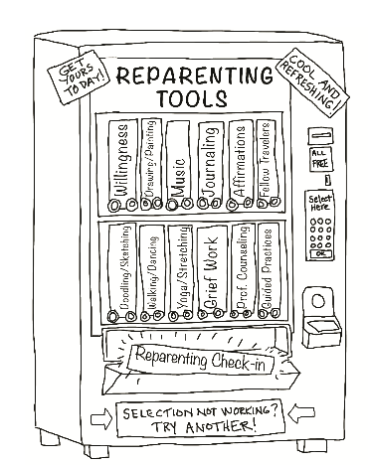 | A vending machine illustration of “Reparenting Tools.” All of the selections are free. At the bottom of the vending machine, a banner says, “Selection not working? Try Another!”. Two post-it notes at the top of the machine state, “Get Yours Today!” And “Cool and Refreshing!”. Someone picked the vending selection “Reparenting Check-in.” Other options are Willingness, Drawing/Painting, Music, Journaling, Affirmations, Fellow Traveler, Doodling/Sketching, Walking/Dancing, Yoga/Stretching, Grief Work, Professional Counseling, Guided Practices.
120 | 217 | 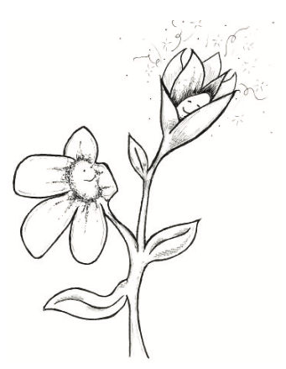 | Flower with two heads. A smiling inner loving parent gazes up at the happy, blossoming inner child flower higher up on the stem.
121 | (i)217 |  | A cupped hand holds a lotus flower above the words Affirmation / Meditation
122 | 221 |  | Text that reads "the power of sharing" with illustration of a lightbulb to the right of it. Inside the lightbulb the filament forms a heart.
123 | 224 | 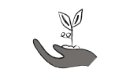 | Dark gray hand holding a sprout
124 | (i)224 | 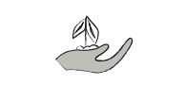 | Gray hand holding a sprout
125 | (i)224 | 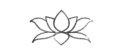 | Gray hand holding a sprout
126 | (i)224 | 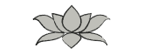 | Gray lotus flower
127 | Back cover | 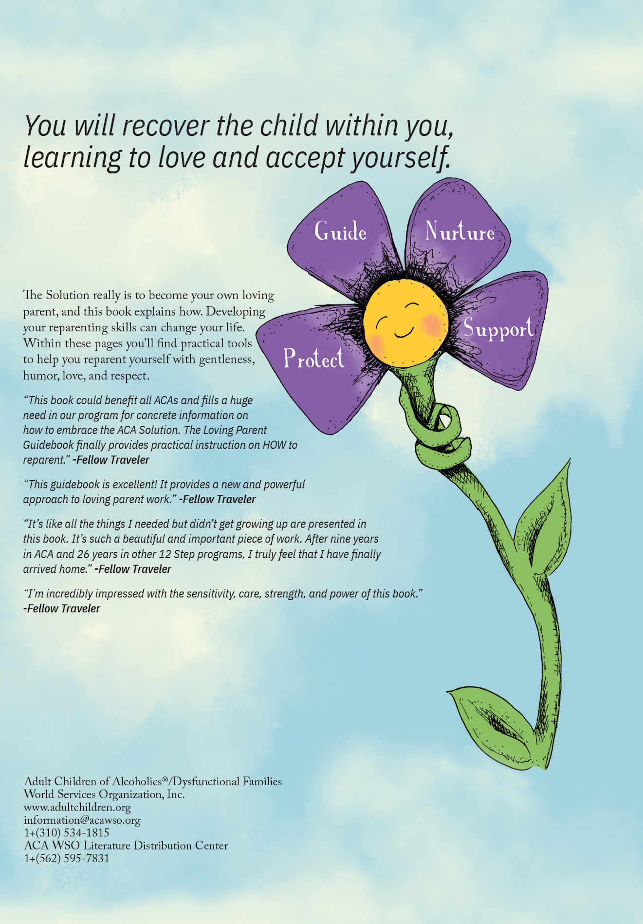 | You will recover the child within you, learning to love and accept yourself. Smiling daisy with a yellow face, eyes closed, with a leaf wrapped around its green stem like a hug. Each of the flower's four purple petals have the needs an inner loving parent meets - Protect, Guide, Nurture, and Support. The Solution really is to become your own loving parent, and this book explains how. Developing your reparenting skills can change your life. Within these pages you’ll find practical tools to help you reparent yourself with gentleness, humor, love, and respect.  “This book could benefit all ACAs and fills a huge need in our program for concrete information on how to embrace the ACA Solution. The Loving Parent Guidebook finally provides practical instruction on HOW to reparent.” -Fellow Traveler  “This guidebook is excellent! It provides a new and powerful approach to loving parent work.” -Fellow Traveler  "It’s like all the things I needed but didn’t get growing up are presented in this book. It’s such a beautiful and important piece of work. After nine years in ACA and 26 years in other 12 Step programs, I truly feel that I have finally arrived home.” -Fellow Traveler  “I'm incredibly impressed with the sensitivity, care, strength, and power of this book.” -Fellow Traveler  Adult Children of Alcoholics®/Dysfunctional Families World Service Organization, Inc.  www.adultchildren.org  information@acawso.org  +1(310) 534-1815  ACA WSO Literature Distribution Center  +1(562) 595-7831

